Rwanda’s Industrial Shift

A Target Strategy for Complexity, Capability, and Growth

# 

# 

# 

# 

# 

# 

# 

# 

# 

# 

# 

# 

# 

# 

# 

# Executive Summary

In the past decades, Rwanda has moved from post-reconstruction into sustained economic progress. GDP per capita rose from US$268 to US$1,075 between 2000 and 2023, and poverty fell from 77% to 55%. Industry and services expanded from just over half of national output to nearly three quarters. These gains show what consistent policy choices can deliver and demonstrate that Rwanda accelerates development when institutions, investment, and sector priorities align.

The next phase of growth requires addressing the structural vulnerabilities that still shape the economy. Minerals account for more than three quarters of export value, and most reported gold exports reflect processed re-exports rather than domestic mining. This concentration creates a narrow base that reacts sharply to global price swings and policy decisions outside Rwanda’s control. Agriculture still employs about 40% of workers while generating 27% of GDP in 2023, limiting productivity growth and leaving many households vulnerable to shocks.

To identify where Rwanda can advance most effectively, this report focuses on exports that reflect domestic value addition. Removing re-exported gold gives a clearer view of the country’s underlying capabilities. On that basis, Rwanda’s Economic Complexity Index (ECI), which measures the diversity and technological sophistication of a country’s export basket, stood at –0.45 in 2023. This report outlines a concrete path to raise ECI to +0.18 by 2033 through a targeted product portfolio and coordinated reforms. Countries that increase economic complexity raise productivity, diversify into higher-value activities, and sustain growth more consistently. For Rwanda, this shift would increase long-run GDP per capita growth from 3.9% to about 5% and shorten the time required to double average incomes by roughly a decade.

The analysis highlights a practical starting point. The Economic Complexity Optimization model identifies 52 products that form Rwanda’s least-cost path to a higher ECI, organized into three strategic clusters: Foundational Upgrades, Adjacent Growth, and Strategic Bets. From within this portfolio, the report highlights seven flagship products, including glues, adhesives, amino compounds, and electrical power accessories. These products span clusters by strengthening formulation and quality capabilities, opening routes into plastics conversion and chemical processing, and positioning firms for entry into regulated niches such as medical instruments and electronic components. They create stepping stones into higher-value segments and reduce reliance on imports that dominate regional markets today.

Capturing this opportunity requires coordinated action. The Rwanda Development Guiding Fund mobilizes blended capital for mid-sized industrial projects that often struggle to secure financing. A fast-lane regulatory track shortens approval timelines for strategic investments. A framework for attracting engineers and technical specialists strengthens the talent base firms need to scale. A public industrial dashboard keeps progress visible to investors, development partners, and citizens.

Together, these instruments form an execution system rather than a collection of isolated reforms. They allow Rwanda to turn strategy into results that can be measured in jobs, production, and export performance.

This roadmap aligns with Vision 2050 and the 2024 to 2034 Industrial Policy. It provides a clear path for Rwanda to compete in sectors where learning is rapid, value addition is high, and regional demand continues to grow. With focus and coordination, Rwanda can strengthen its position as an emerging industrial hub in East and Central Africa.

## Table of Contents

—

Executive Summary 3

Table of Contents 5

Introduction 8

Economic Potential and Diversification Opportunities 8

Economic Potential and Diversification Opportunities 9

Chapter 1 11

The Economic Complexity of Rwanda 11

Chapter 1 12

The Economic Complexity of Rwanda 12

Why Complexity Matters 15

From Diagnosis to Direction 16

Rwanda’s Diversification Frontier 17

Feasibility in Context: Thresholds That Shape Rwanda’s Options 19

What’s at Stake 19

Chapter 2 21

Opportunity Landscape 21

Chapter 2 22

Opportunity Landscape 22

Flagship 1: HS 3208 – Nonaqueous Paints 23

Flagship 2: HS 3506 · Glues & Adhesives 27

Flagship 3: HS 3819 · Hydraulic Brake Fluid 31

Flagship 4: HS 2922 · Oxygen-Function Amino Compounds 35

Flagship 5: HS 3922 – Plastic Wash Basins 39

Flagship 6: HS 9018 – Medical Instruments 43

Flagship 7: HS 8538 – Electrical Power Accessories  48

Flagship 8: HS 8473 – Office Machine Parts 52

How the Portfolio Works Together 56

Chapter 3 57

Making It Happen 57

Chapter 3 58

Making It Happen 58

Rwanda Development Guiding Fund 58

Open Economy for Knowledge Workers 60

Fast-Lane Regulation — Unblocking Projects in 120 Days 62

Transparency & Accountability — Turning Strategy into a System 63

What Success Looks Like 65

Conclusion & Next Steps 66

Reflections from Our October Mission to Kigali 68

Appendix 70

SECTION GLOSSARY 70

1 Data Sets 71

2 Complexity & Relatedness​​ 71

**2.1 The Logic of Economic Complexity** 71

**2.2 Relatedness and the Product Space** 75

3 Growth, Inequality & Emissions Models 76

**Growth-Forecast Regression** 76

**Emissions-Forecast Regression** 77

**Inequality-Forecast Regression** 78

4 Export-Portfolio Optimization (ECI-OPT) 80

5 Cluster Snapshot and Full Product List 82

REFERENCES — 91



# 

# Introduction

# Economic Potential and Diversification Opportunities

# 

# Economic Potential and Diversification Opportunities

Rwanda’s long-term development depends on raising productivity in current sectors and expanding into more sophisticated activities. Global evidence shows that economies that export more complex products grow faster, sustain higher income levels, and adapt more effectively to external shocks. This pattern is captured by the Economic Complexity Index (ECI)1,3,5,6, a measure of productive capabilities that is a strong predictor of long-term economic growth1,3,5,7–14.

This report applies the Economic Complexity Optimization (ECI-OPT) model (Stojkoski & Hidalgo, 2025) to identify these opportunities. The model produces a balanced portfolio of 52 products that maximize potential complexity gains while remaining feasible given Rwanda’s current capabilities. It replaces sector heuristics with empirical optimization and highlights activities where incremental steps yield the strongest capability upgrades.

The resulting portfolio follows a coherent capability path. It begins with routine-intensive activities such as blending, packaging, and quality control, which strengthen standardization and process discipline. From there, it moves into plastics conversion, milling, and chemical processing, creating entry points into precision manufacturing in regulated sectors.

To keep the diversification strategy grounded in Rwanda’s operational realities, the portfolio recommended by the ECI-OPT model includes only products that meet basic feasibility criteria tied to logistics and capabilities. An explanation of these thresholds appears in Chapter 1, where they are applied systematically to the opportunity set.

Overall, the analysis indicates clear room for higher-value and more complex production. Advancing this product portfolio through coordinated policy, blended finance, and targeted skills development can shift Rwanda toward capability-driven growth that raises job quality and strengthens competitiveness.

# 



# 

# 

# Chapter 1

# The Economic Complexity of Rwanda

# Chapter 1

# The Economic Complexity of Rwanda

According to Rwanda’s official external trade statistics, goods exports increased from US$703 million in 2013 to US$2.466 billion in 2023. Excluding gold, exports totaled US$1.582 billion, highlighting how re-exported gold shapes the aggregate. These figures come from NISR’s Formal External Trade in Goods series, based on customs declarations compiled under IMTS 2010 and published mainly in SITC commodity sections.

Measuring complexity requires complete and comparable data. For this reason, the report uses the BACI-based OEC dataset, which provides a harmonised HS4 structure across trading partners and the product detail needed to position Rwanda within the international product space. The analysis focuses on no-gold exports to isolate underlying capabilities. Core no-gold exports reached US$461 million in 2023, concentrated in coffee, tea, wolfram, and coltan. These products reflect Rwanda’s most established capabilities and form the platform from which broader diversification can occur.

Figure 1. Core No-Gold Exports (BACI 2023): A Base for Diversification

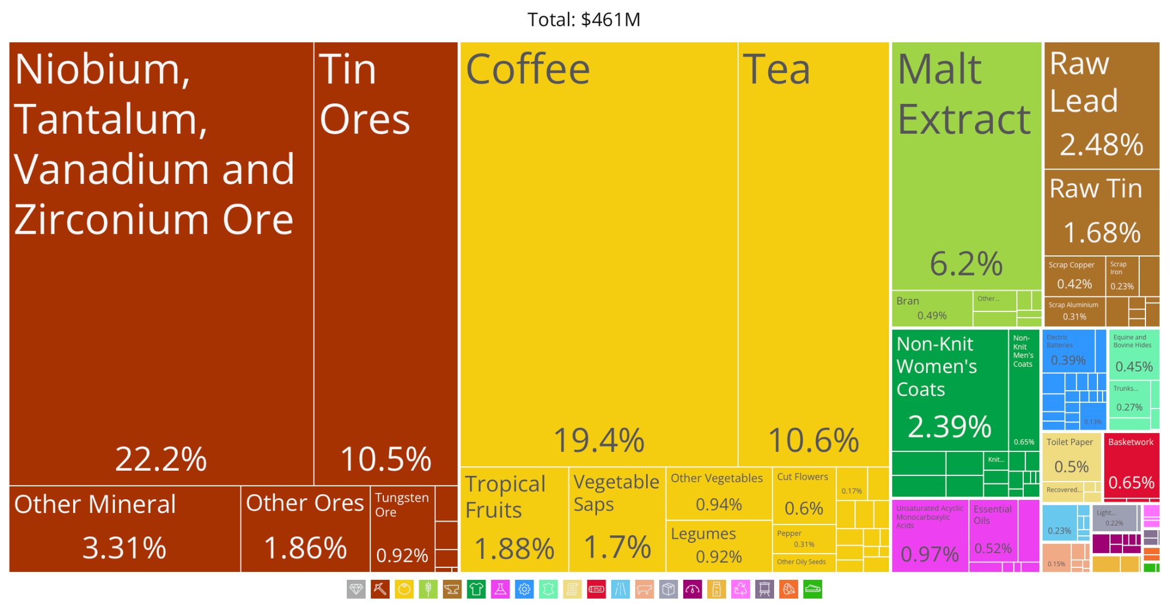

Excluding gold, Rwanda’s US$461M export basket is led by minerals, coffee, and tea, with early footholds in food preparation, apparel, chemicals, and light manufacturing that provide a basis for further diversification.

Limited export diversification is consistent with Rwanda’s current stage of industrial development. Over the past three decades, the country’s export structure has rotated across a narrow set of primary products—coffee in the 1990s, refined petroleum re-exports in the 2000s, and tin ores in the 2010s. Each surge contributed to short-term growth but left the production base concentrated in activities with modest spillovers and limited technological depth. More recently, small footholds have emerged in food preparation, apparel, chemicals, and light manufacturing, yet these remain marginal relative to agriculture and minerals.

Figure 2. Core No-Gold Exports (1995–2023)

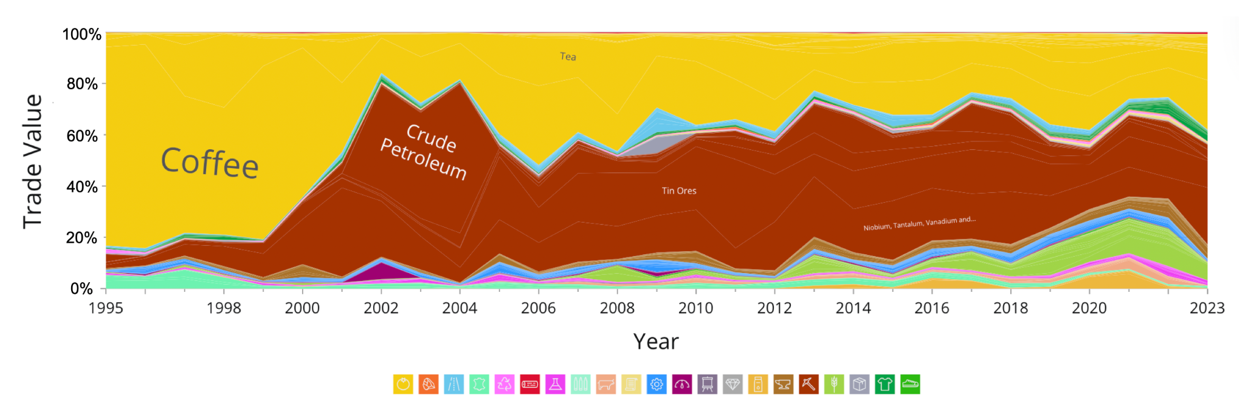

Manufactured exports have begun to appear but remain small relative to minerals and agricultural products.. Petroleum-related entries in the data correspond to re-exports of HS 2710; Rwanda does not export crude oil (HS 2709).

Despite these emerging signs of diversification, Rwanda’s economic complexity remains moderate. On a no-gold basis, the Economic Complexity Index (ECI) stands at –0.45 (2023), a level associated with economies concentrated in a limited set of capabilities. This reflects a structure where a few primary products account for most export earnings, and where the connections to more knowledge-intensive goods remain thin.

Figure 3. ECI Rankings by Country (2023)

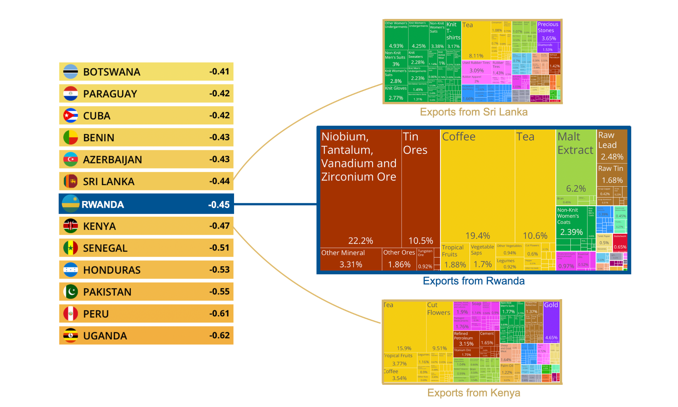

Higher positions reflect broader and more knowledge-intensive export bases among peer economies.

The result is a growth model that remains exposed to price volatility and difficult to sustain. When commodity prices rise, activity accelerates; when they fall, vulnerability increases. Without structural change, Rwanda risks remaining in a narrow productive base that earns foreign exchange but captures limited spillovers.

## Why Complexity Matters

Economic complexity measures the knowledge embedded in a country's productive structure. The ECI synthesizes how sophisticated a country’s exports are using trade data as a proxy for the presence of productive capabilities.

Empirical evidence shows that ECI outperforms other fundamentals—such as education levels, institutional quality, or competitiveness rankings—at predicting long-term GDP per capita growth.5 It also helps explain global differences in income inequality15 and greenhouse gas emissions per unit of GDP.20

With an ECI of –0.45 on a no-gold baseline, Rwanda currently lies near the mid-range of global economies. The challenge is to translate this progress into a broader base of higher-value production. By embedding new knowledge into manufacturing and services, Rwanda can shift from growth driven by volume to growth driven by capability.

Figure 4. Economic Complexity vs. GDP per capita (2021–2023)

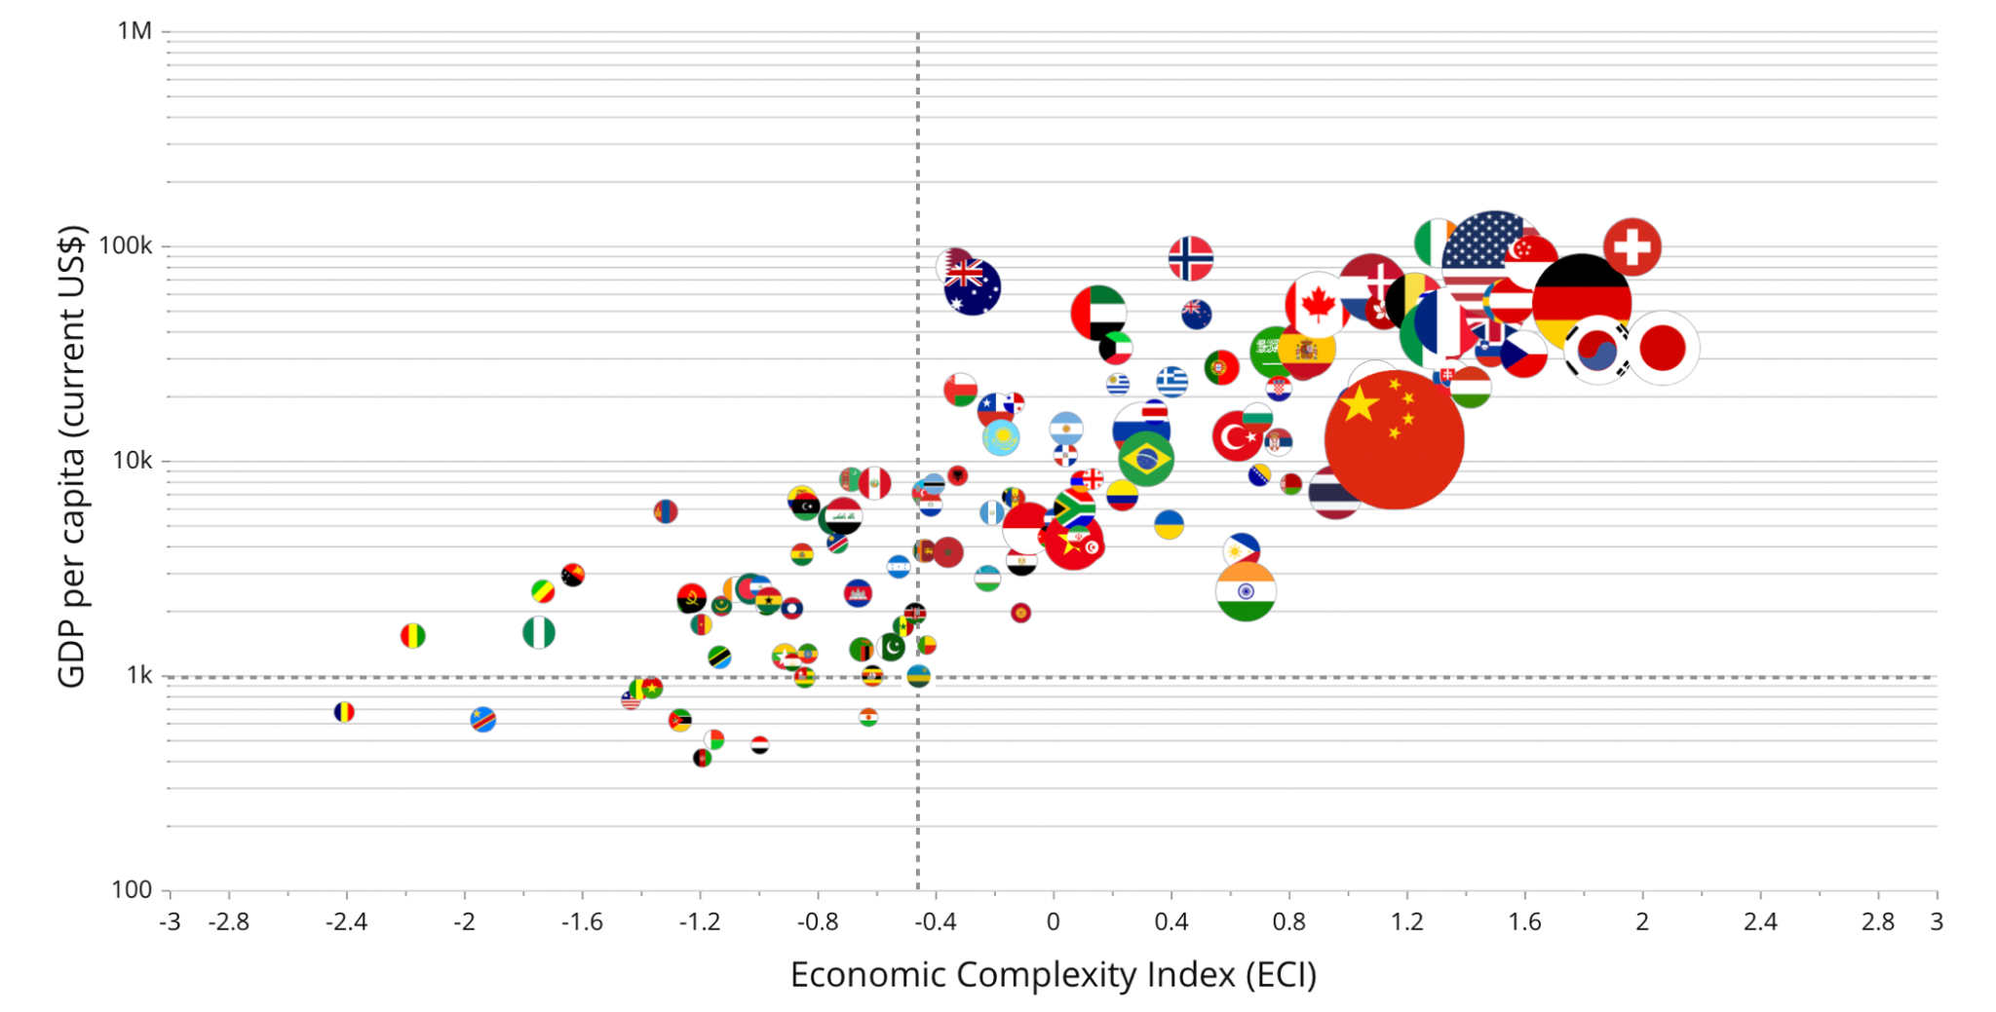Countries with higher complexity achieve higher income levels over time; points further “up and to the right” combine higher complexity with higher income. See Appendix 2 for methodological details.

### From Diagnosis to Direction

Rwanda’s exports reveal what the country already knows. This is the essence of economic complexity: nations accumulate productive capabilities that shape what they can make today—and what they are able to make next. Economic complexity therefore helps identify not only a country’s current strengths but also its most feasible paths for future diversification.

Rwanda’s current strengths—coffee, niobium, and tin ores—exhibit Revealed Comparative Advantage (RCA > 1). The figure below situates these products within the product space, a network that maps goods commonly co-exported around the world. Products positioned close to Rwanda’s exports tend to require similar skills, inputs, and infrastructure, making them easier entry points. This mapping helps estimate how feasible it would be for Rwanda to branch into new activities. Today, Rwanda sits near the periphery of the network but has clear potential entry paths through textiles, chemicals, and plastics.

Figure 5. Rwanda’s Core No-Gold Product Space

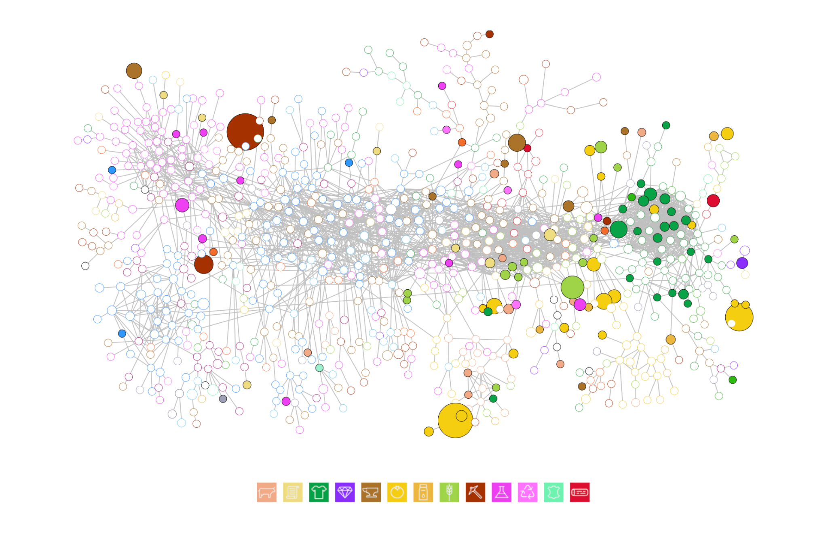Products with RCA>1 in Rwanda are highlighted. Proximity on the map reflects similarity of required capabilities; connected nodes are more feasible next steps. (See Appendix Section 2 for details).

Valuable as they are, these existing niches remain narrow and weakly connected, offering limited pathways into more complex industries. The challenge is to identify products that anchor to Rwanda’s current base while opening routes toward higher sophistication. By quantifying the feasibility of each potential product and combining those estimates with measures of complexity, we can define a cost-effective strategy for structural transformation.

## Rwanda’s Diversification Frontier

One way to visualize Rwanda’s diversification opportunities is through the diversification frontier, which plots each product according to two dimensions: relatedness and product complexity. Relatedness2,4 measures how strongly a potential product connects, through shared capabilities, to those that Rwanda already exports. Countries are empirically more likely to enter products with higher relatedness, since these require familiar inputs, technologies, and supplier networks. Product complexity, by contrast, reflects how knowledge-intensive a product is and how much it contributes to long-run growth.

Plotted together, these dimensions reveal clear trade-offs. The lower-right quadrant highlights quick wins: products that are easy to enter but modest in complexity. The upper-left quadrant points to stretch bets that are harder to enter but offer larger capability gains.

Figure 6. Rwanda’s Core No-Gold Diversification Frontier

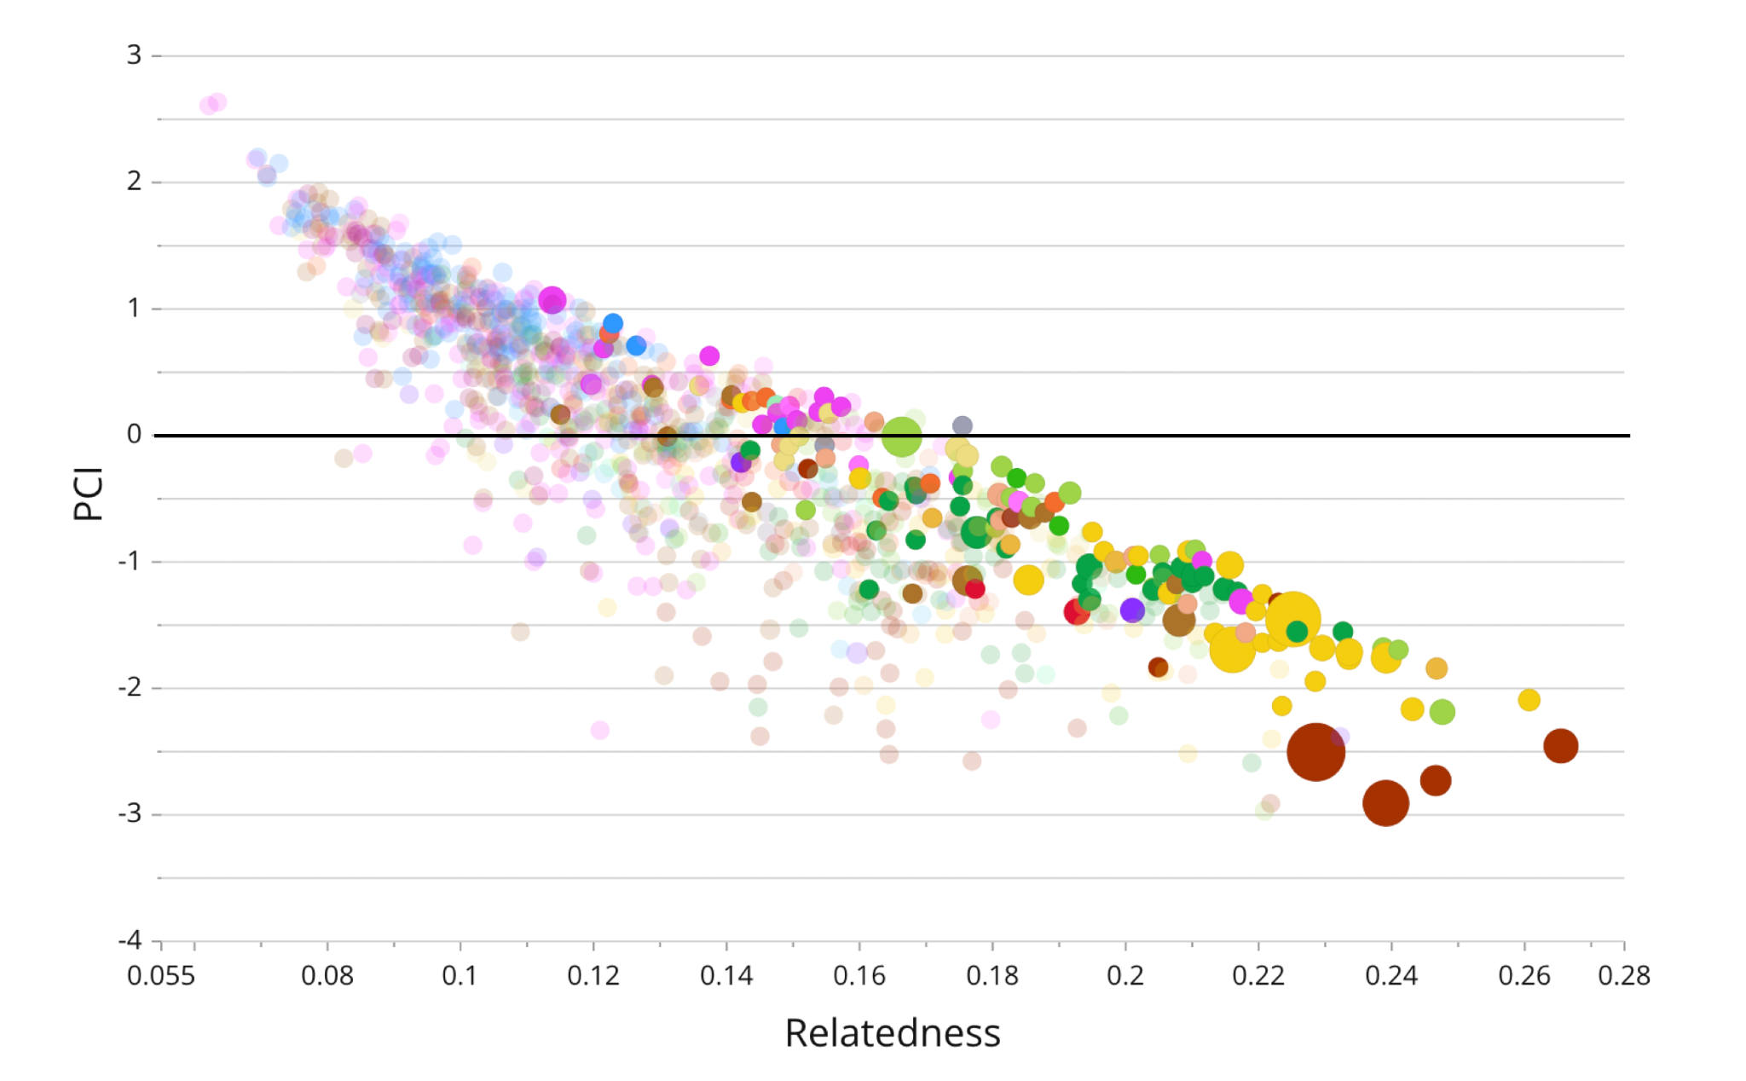Each dot represents a product. The horizontal axis shows relatedness, which indicates ease of entry, and the vertical axis shows complexity, which reflects development potential. Products farther to the right sit closer to Rwanda’s current capabilities; those higher up promise larger long-term gains.

This trade-off defines Rwanda’s core challenge. Near-term opportunities are achievable and support early industrial growth, but they do not shift the structure of the economy on their own. Higher-complexity options are transformative yet require stronger institutions, stricter quality systems, and deeper investment. The frontier is therefore a diagnostic tool rather than a target. It helps policymakers identify products that balance feasibility with impact and sequence diversification so that early wins build the capabilities needed for more advanced entry.

Combined with the optimization model, the frontier becomes a roadmap. It links immediate opportunities with longer-term capability accumulation and helps Rwanda convert potential into sustained industrial learning and complexity-driven growth.

### Feasibility in Context: Thresholds That Shape Rwanda’s Options

A product may seem feasible on paper but can still fail in practice. For Rwanda, two constraints are decisive in determining which diversification opportunities are realistic and viable.

1. **Logistics threshold.** As a landlocked economy, Rwanda faces high transport costs that erode margins for low-value or bulky goods. To be viable, potential exports must exceed a unit-value floor of US$1,654 per tonne, corresponding to the 25th percentile of global export prices.
2. **Capability threshold.** At Rwanda’s development stage, peer economies typically specialize in products with a Product Complexity Index (PCI) of 1 or below. Focusing on this range prioritizes near-term entries that reinforce the operational routines, supplier networks, and quality systems required to transition into more complex industries.

These thresholds ensure that diversification remains anchored in practical constraints, not theoretical potential, and that progress reflects genuine accumulation of skills, inputs, and institutional readiness.

## What’s at Stake

If Rwanda advances the 52 near-term products identified in this report, supported by reforms in investment de-risking, skills development, fast-lane regulation, and digital infrastructure, the country can shift from concentration-driven earnings to capability-driven growth.

This shift would reduce reliance on re-exports and commodities by embedding new technical know-how into production systems and expanding technological capabilities across sectors. As firms gain experience in blending, packaging, quality control, and certification, they establish the foundation required for more complex manufacturing in plastics, electronics, and medical devices.

The gains extend beyond export diversification. A more sophisticated production base raises the quality of industrial jobs, reduces vulnerability to external shocks, and broadens Rwanda’s fiscal and innovation space. Moving toward knowledge-intensive production also supports environmental and social goals by lowering emissions per unit of GDP and expanding participation in growth.

The core question is not only how fast Rwanda grows but how it grows. By moving from an economy that relies on scale to one that builds and applies capabilities, Rwanda can anchor long-term prosperity in the skills of its firms and workforce and set a durable path toward inclusive and sustainable industrialization.

|  |  |  |  |
| --- | --- | --- | --- |
| **Indicator** | **Baseline** | **Target\*** | **Why it matters** |
| **Economic Complexity (ECI)** Core No-Gold** | –0.45 | +0.18 | Predictor of growth, jobs, resilience |
| **GDP per capita growth (annual)** | 3.9 % | ~5.0 % | Faster compounding, more fiscal space |
| **Emission intensity (kt CO₂-eq / bn USD GDP)** | 551 | 432 | –21.6 % per unit, even without cleaner fuel mix |
| **Inequality (Gini index)** | 52.3 | 52.3 | Stable distribution of income as complexity rises |

*\* Targets assume successful specialization in the* [*52 products identified*](https://docs.google.com/spreadsheets/d/1cq3TxHXTtufEiN2hgNY9oL8NuZHANn7Wl_5v_gWhbbM/edit?gid=1347715044#gid=1347715044) *through the ECI-OPT model. See Appendix 4 for the full list.*

*\*\** ***ECI is standardized relative to the world average (0).*** *Moving from –0.45 (Rwanda, 2023) to +0.18 would lift Rwanda from below to slightly above the world average.*



# Chapter 2

# Opportunity Landscape

# Chapter 2

# Opportunity Landscape

This chapter applies the ECI-OPT results to identify concrete diversification paths. It highlights eight flagship products grouped into three strategic clusters that represent progressively deeper capability development: Foundational Capability Upgrades, Adjacent Growth Opportunities, and Strategic Innovation Bets. These products build on Rwanda’s existing strengths while opening entry points into more complex activities.

Each flagship is assessed using a common set of indicators that capture feasibility, capability gains, and market potential. RCA shows whether Rwanda already exports the product competitively. PCI reflects its knowledge intensity. Relative relatedness measures how close the product is to Rwanda’s current capabilities. Target ECI Growth indicates its expected contribution to complexity improvement. E&MA Imports, Top Markets, and Fastest-Growing Markets describe accessible regional demand. The price range (US$/t, P10/P50/P90) captures variation in global shipment-level unit values and signals the range of specifications Rwanda would need to match.

Together, these indicators identify products that combine feasible near-term entry with meaningful capability upgrades. They point to areas where Rwanda can compete today, where certification and process improvements unlock higher-value segments, and where regional demand can support sustained industrial learning.

A simple example illustrates how the model evaluates feasibility. For HS 3208 (Nonaqueous Paints), a relative relatedness score of 0.73 shows that many required inputs and routines already exist. The product’s PCI of 0.59 lies a standard deviation above Rwanda’s current ECI but remains attainable. The model then estimates the RCA increase needed to reach competitiveness, defined as RCA of at least one. HS 3208 emerges as a priority because it delivers a measurable complexity gain with a relatively modest capability gap. The remaining flagships follow the same logic.

### [Flagship 1: HS 3208 – Nonaqueous Paints](https://oec.world/en/profile/bilateral-product/office-machine-parts/reporter/rwa)

**Cluster:** Adjacent Growth Opportunities

|  |  |  |  |  |  |
| --- | --- | --- | --- | --- | --- |
| **PCI** | **Rel. Relat.** | **E&MA imports (US$M)** | **Entry SKUs** | **Key QA/cert** | **Supply gaps Rwanda can target** |
| 0.59 | +0.73 | 191.3 | Primers; enamels; waterproof coatings; road-marking paints | ISO 12944; ISO 9001 | Industrial coatings; road-marking systems; mid-tier protective paints |

**Opportunity Overview**

Eastern and Middle Africa imported US$191.3 million of nonaqueous paints in 2023, a 31.5% increase since 2018. Rwanda’s own market has grown at more than 20% annually from 2019 to 2022, reaching about US$1 million. The product aligns well with Rwanda’s current capabilities. Its PCI of 0.59 and relatedness of +0.73 link directly to Rwanda’s experience in adhesives (HS 3506) and plastics (HS 3922). Building formulation capacity strengthens dispersion control, viscosity management, batch traceability, and testing routines that support broader upgrading in chemicals and polymers.

**Current Foundations**

Rwanda hosts several paint producers, but current capacity remains far below national demand. [AMACO Paints](https://en.amacopaints.rw/our-products/) in Gahanga Industrial Park manufactures decorative, automotive, and industrial coatings and exports to the DRC, yet supplies less than 10% of domestic consumption. Other firms, including Maxoline, operate at similar scale. All rely on imported acrylic resins, pigments, solvents, and additives. High input costs stem from fragmented orders, long lead times, and the absence of shared bulk-storage infrastructure that could lower unit costs.

Quality assurance is the primary constraint. Rwanda lacks an accredited coatings laboratory, preventing firms from certifying to ISO 12944 or ISO 9001. Without certification, producers cannot access procurement markets in construction, roads, utilities, and industrial maintenance, limiting the sector to low-spec decorative products even as domestic demand rises.

**Market and Competitiveness Opportunity**

|  |  |  |  |  |
| --- | --- | --- | --- | --- |
| Top importers (E&MA, 2023) | Value (US$M) | Fastest‑growing importers (2018–2023, CAGR) | CAGR | Price range (US$/t, P10/P50/P90) |
| Egypt | 32.1 | DRC | 13.7% | 864 / 4,678 / 10,041 |
| Kenya | 23.9 | Cameroon | 12.4% |
| Tanzania | 19.1 | Gabon | 11.9% |

EAC demand for nonaqueous paints rose 63.3% in 2023, supplied largely by the UAE, India, Italy, and Uganda, which signals that regional production still covers only a narrow set of specifications.

East African Community (EAC) Imports of Nonaqueous Paints

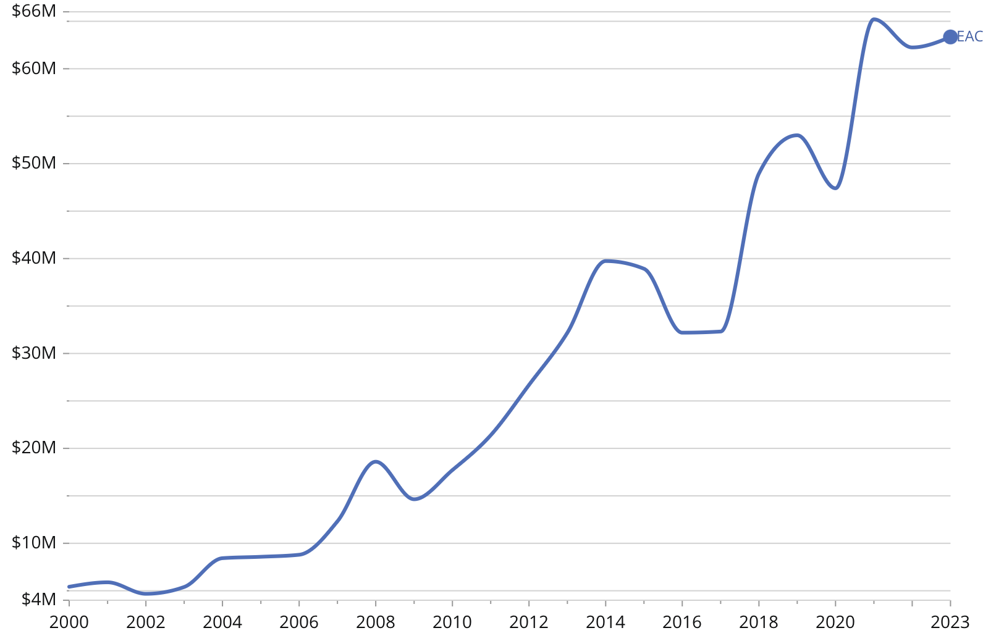

EAC import structures expose clear capability gaps. Kenya’s US$9.1M market depends on Italy (35%) and Egypt (26%), showing unmet demand for industrial and automotive coatings that require certified performance. Tanzania’s US$3.6M mix from Italy (26%) and China (16.3%) reflects a split between high-spec protective products and low-cost general-purpose paints. Uganda’s US$7.5M reliance on India (67%) signals persistent shortages in standard industrial paints where batch consistency is essential.

The EAC’s 35% Common External Tariff raises landed prices for extra-regional suppliers and gives local firms a cost margin if they meet basic QA and supply reliably. Freight costs and lead times strongly influence procurement decisions in these segments. Rwanda can enter where responsiveness and consistent batches matter most: road-marking paints, primers, and waterproof coatings. With accredited testing, Rwanda can expand into certified protective coatings for construction, transport, and energy infrastructure, a higher-value segment still dominated by extra-regional producers.

**Investment and Capability Roadmap**

Rwanda can build competitiveness through a phased plan. In the first year, firms should expand blending and dispersion capacity to 2–3 million liters annually with an investment of US$2.5–3.0 million, focusing on primers, enamels, waterproofing, and road-marking paints. A shared bulk-input facility in the Kigali SEZ, costing about US$1.5 million, would consolidate imports of resins, solvents, and pigments and reduce freight volatility by enabling larger shipments.

Between months 12 and 36, Rwanda should establish an accredited coatings laboratory capable of certifying to ISO 12944 and ISO 9001. Adding colorimetry, accelerated-weathering, adhesion, and corrosion-resistance testing will allow producers to meet regional technical requirements. With this capability in place, firms can introduce higher-value industrial coatings for infrastructure and construction across the EAC.

From year three onward, Rwanda should expand distribution into eastern DRC and Bujumbura, supported by regional hubs and tinting centers that shorten lead times and allow on-site customization. Long-term resin supply agreements will stabilize input costs and improve competitiveness. At this stage, Rwanda can move into premium protective systems for logistics, industrial, and infrastructure projects, shifting the sector toward higher-value, specification-driven production.

**Benchmark Case**

[**Crown Paints**](https://www.crownpaints.co.ke/about-us/) (Kenya) produces about 3 million liters per month and operates in Uganda, Tanzania, and Rwanda. Its scale and quality-management systems enable participation in government and private tenders. [**Basco Paints**](https://interiors.co.ke/basco-paints/) (Duracoat, Kenya) reports installed capacity of about 22 million liters per year and expanded water-based output by roughly 50% in 2022 with a new emulsion plant. [**Uganda**](https://oec.world/en/profile/bilateral-product/nonaqueous-paints/reporter/uga#market-growth) exported US$3.88 million of HS 3208 in 2023, mainly to South Sudan (57%), Burundi (28%), and the DRC (14%), illustrating the role of regional demand and distributor networks in scaling production.

### 

### [Flagship 2: HS 3506 · Glues & Adhesives](https://oec.world/en/profile/bilateral-product/glues/reporter/rwa)

**Cluster: Foundational Capability Upgrades**

|  |  |  |  |  |  |
| --- | --- | --- | --- | --- | --- |
| PCI | Rel. Relat | E&MA imports (US$M) | Entry SKUs | Key QA / certification | Supply gaps Rwanda can target |
| 0.85 | −0.44 | 138.6 | PVAc wood glues; PU sealants; solvent cements | ISO 9001; ASTM D1084; ISO 4587 | Construction adhesives; waterproof sealants; packaging hot-melts |

**Opportunity Overview**

Adhesives are critical inputs for construction, packaging, furniture, and automotive repair. Regional imports reached US$138.6M in 2023 and grew 9.4% annually since 2018, one of the fastest expansions among mid-complexity chemicals in Eastern and Middle Africa. Import values have risen faster than volumes, indicating a shift toward higher-performance products such as water-based PVAc, polyurethane sealants, and hot-melt systems.

With a PCI of 0.85, adhesives sit above Rwanda’s current capability base but remain attainable. Rwanda exported US$358,000 of HS 3506 in 2022, mainly to the DRC, confirming early access to regional buyers and the feasibility of cross-border distribution. Building a domestic formulation industry would lower the import bill, strengthen polymer-processing capabilities, and support Rwanda’s movement into higher-value specialty chemicals.

**Current Foundations**

Rwanda has no large-scale adhesive producer, but it holds several relevant assets. Polymer-processing firms such as [EcoPlastic Rwanda](https://ecoplasticrwanda.com) and the new US$50M compostable-packaging plant already operate blending and dispersion equipment that can support adhesive formulation. The Rwanda Standards Board has experience with accreditation, traceability, and ISO-aligned quality systems, all of which are essential for certification-intensive chemical production. The Kigali SEZ provides appropriate infrastructure and streamlined customs processes for chemical manufacturing and warehousing.

Important gaps remain. Rwanda does not yet have dedicated formulation equipment, certified test laboratories that comply with ISO 9001 or ISO 14001, or testing protocols such as ASTM D1084 and ISO 4587. The country also lacks technicians trained in chemical blending, process control, and quality management.

Capabilities developed in adhesives and coatings, including formulation control, batch traceability, and routine quality-assurance testing, offer a base for later entry into precision or regulated industries. Medical-device assembly, however, requires ISO 13485–compliant clean rooms that must be physically separated from chemical-processing lines. A single firm may operate in both segments, but production areas, air-handling systems, sanitation protocols, and documentation procedures must be fully segregated to meet regulatory requirements.

**Market and Competitiveness Opportunity**

|  |  |  |  |  |
| --- | --- | --- | --- | --- |
| **Top importers (E&MA, 2023)** | **Value (US$M)** | **Fastest-growing importers (2018–2023, CAGR)** | **CAGR** | Price range (US$/t, P10 / P50 / P90) |
| Kenya | 24.3 | Ethiopia | 13.6% | 900 / 2,850 / 10,000 |
| Tanzania | 18.8 | Tanzania | 12.5% |
| Ethiopia | 15.9 | Kenya | 11.2% |

Adhesives operate in a two-tier market. Commodity glues from China and the UAE sell below US$2,000 per tonne, while industrial and packaging adhesives from Germany, Italy, and India exceed US$40,000 per tonne. Median import prices in 2023 reached US$2,850 per tonne (IQR US$900–10,000), indicating substantial demand for premium formulations in East Africa.

Eastern Africa accounts for 65% of regional demand and pays about 23% more per tonne than Middle Africa, reflecting stricter quality requirements. Kenya, Tanzania, and Ethiopia form the high-value core, while Angola and the DRC dominate the lower-spec segment.

Rwanda already holds a significant position. Intra-EAC adhesive trade totaled US$7.1M in 2023, and Rwanda supplied 31% (US$2.18M), ahead of Uganda and Tanzania. Demand for construction adhesives, waterproof sealants, and packaging hot-melts favors localized blending, where short delivery times, technical support, and product customization shape purchasing.

East African Community (EAC) Internal Trade: Glues & Adhesives

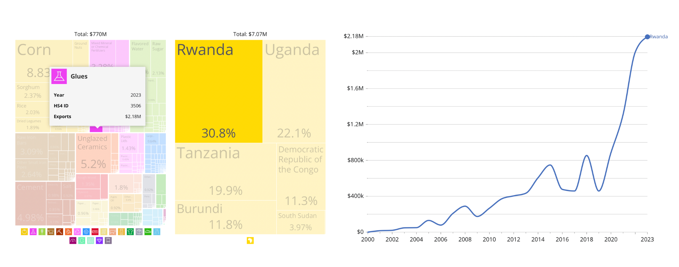

**Investment and Capability Roadmap**

A phased approach allows Rwanda to build capability while containing risk. In the first phase, a pilot formulation facility of US$2–5M could produce water-based glues and simple solvent cements for packaging and woodworking. The focus would be on blending imported inputs, setting up basic quality testing, and training technicians in polymer handling and batch control.

The second phase would scale output to 1,000–2,000t per year with an investment of US$15–25M. At this stage, producers could supply regional demand for construction adhesives, grouts, and packaging hot-melts. The expansion would add packaging and filling lines, establish basic R&D for bio-based formulations, and work toward ISO 9001 and ISO 14001 certification.

In the longer term, Rwanda could develop integrated resin and binder production using inputs such as cassava starch or pine resin, aligning with circular-economy objectives and reducing dependence on imported polymers.

**Benchmark Case**

South Africa provides the strongest regional benchmark. Its adhesives sector, anchored by Henkel, Arkema-Bostik, Sasol Chemicals, and Permoseal, links local feedstock production with advanced formulation and consistent exports. In 2021, South Africa exported US$18M of HS 3506 to SADC markets, driven by high-margin hot-melt and industrial adhesives. Its competitiveness reflects proximity to chemical feedstocks, efficient logistics, and targeted incentives including tax breaks and customs facilitation.

Rwanda does not have South Africa’s feedstock base but can replicate its cluster design, quality infrastructure, and sustainability orientation. Henkel’s solar-powered operations illustrate a viable model for Rwanda’s green-industry goals. Concentrating adhesive production in the Kigali SEZ, integrating it with plastics and packaging firms, and investing in accredited testing would create a cost-efficient, capability-intensive entry path aligned with regional demand.

### 

### [Flagship 3: HS 3819 · Hydraulic Brake Fluid](https://oec.world/en/profile/bilateral-product/hydraulic-brake-fluid/reporter/rwa)

**Cluster:** Foundational Capability Upgrades

|  |  |  |  |  |  |
| --- | --- | --- | --- | --- | --- |
| **PCI** | **Rel Relat** | **E&MA imports (US$M)** | **Entry SKUs** | **Key QA / certification** | **Supply gaps Rwanda can target** |
| 0.86 | −0.30 | 27.2 | DOT-3; DOT-4; DOT-4 LV | ISO 4925; FMVSS 116; ISO 9001 | Bulk brake fluid for Eastern Africa; premium DOT-4 LV for Middle Africa |

**Opportunity Overview**

Hydraulic brake fluid is a central input in Eastern and Middle Africa’s automotive aftermarket. In 2023, the two regions imported US$27.2M across nearly 13,000t. Although volumes fell from 2022, imports still grew 6.8% over 2018 to 2023, driven by expanding vehicle fleets, public transport systems, and logistics activity.

Rwanda imported close to US$1M of brake fluid in 2022. Exports once peaked at US$46,000 in 2018 but have since declined as producers in Kenya, Tanzania, and Zambia strengthened their position. With a PCI of 0.86, brake fluid sits above Rwanda’s current ECI but aligns with existing capabilities in blending, quality assurance, and packaging that originate from lubricants (HS 2710) and adhesives (HS 3506). The product offers a clear import substitution opportunity and supports regional supply growth that is consistent with Vision 2050 and the 2024 to 2034 Industrial Policy.

**Current Foundations**

​​Local production is anchored by [**Africa Lubricant Manufacturing Co. (ALMC)**](https://rymax-lubricants.rw), a joint venture between Société Pétrolière (SP) and Rymax Lubricants of the Netherlands. Its ISO 9001-certified blending plant in the Kigali Special Economic Zone is estimated to produce 1,500t annually, blending base oils and additives to global standards (ISO 4925, FMVSS 116). Inputs are sourced from Europe and Asia, while packaging comes from local firms such as Inyange Plastics.

This concentrated production base is an asset but also a vulnerability. ALMC demonstrates Rwanda’s blending and certification capabilities, but the country remains dependent on imported base oils and additive packages. Limited bulk storage further raises costs and constrains competitiveness.

**Market and Competitiveness Opportunity**

|  |  |  |  |  |
| --- | --- | --- | --- | --- |
| **Top importers (E&MA, 2023)** | **Value (US$M)** | **Fastest-growing importers (2018–2023, CAGR)** | **CAGR** | **Price range (US$/t, P10 / P50 / P90)** |
| Angola | 6.1 | Djibouti | 21.5% | 348 / 1,145 / 15,000 |
| Kenya | 3.8 | Somalia | 19.8% |
| Tanzania | 3.7 | DR Congo | 13.7% |

Demand divides into two distinct markets. Eastern Africa imported US$9.3M and 8,100t of brake fluid in 2023 and is primarily volume driven. Average prices were about US$1,145 per tonne, with large low-cost consignments such as the UAE’s 4,800t at US$348 per tonne. Middle Africa imported US$17.9M and 4,800t and shows a higher-value mix. Average prices were close to US$3,700 per tonne, and premium shipments from Switzerland and Germany reached US$15,000 per tonne.

The supplier base is moderately concentrated. Belgium supplied US$8.1M, or 29.8%, and the United Kingdom supplied US$5.8M, or 21.2%. South Africa supplied US$3.1M, or 11.5%. India, the UAE, and China dominated the lower-priced segment. Belgium, China, and South Africa all increased their share between 2018 and 2023, indicating stronger production capability and distribution reach.

For Rwanda, this dual structure offers two entry paths. Domestically, replacing its US$1M import bill is achievable with existing facilities. Regionally, Rwanda can compete in the bulk segment of Eastern Africa on cost and then upgrade into higher-value specifications for Middle Africa where certification and quality assurance determine market access. The blending and testing infrastructure required for brake fluids also supports adhesives, specialty chemicals, and lubricants, which lowers unit costs across the cluster.

**Investment and Capability Roadmap**

A phased strategy can scale Rwanda’s brake fluid industry. In Phase 1, ALMC can expand with a dedicated 3,000 tonne per year line and new bulk storage for glycol ethers at an estimated cost of US$1.2M. This would meet domestic demand and open opportunities in nearby markets such as the DRC, Burundi, Zambia, and Uganda, which together import more than US$4M per year.

Phase 2 should focus on premium specifications by securing ISO 4925 Class 6 and FMVSS 116 certifications for advanced DOT 4 LV fluids used in ABS systems and electric vehicles. This positions Rwanda for Middle Africa’s higher-value segment, where European suppliers currently dominate. Integrating renewable energy into ALMC operations would align production with Rwanda’s green industrialization objectives.

Policy instruments will play a central role. Customs duty remission on additives, export financing through the Export Growth Fund, and skills partnerships with technical institutes can lower production costs and accelerate certification.

**Benchmark Case**

Tanzania offers a relevant regional model. [Total Tanzania](https://www.totalbusiness.com/tz/)’s US$20M blending plant in Dar es Salaam produces 22,000t of lubricants and 2,000t of greases annually and includes brake fluids for domestic use and export to Kenya, Rwanda, and Zambia. The facility benefits from partnerships with oil majors, co-location with port infrastructure for low-cost input sourcing, and in-house laboratories certified to international standards. Its success demonstrates how early investment in certification, integrated logistics, and multi-product blending can secure regional market share.

For Rwanda, the lesson is clear. Integrating brake fluid lines into existing lubricant facilities, prioritizing certification, and leveraging regional trade corridors provides a scalable and cost-efficient pathway that aligns with SEZ development and AfCFTA export ambitions.

### 

### Flagship 4: HS 2922 · Oxygen-Function Amino Compounds

Cluster: Adjacent Growth Opportunities

|  |  |  |  |  |  |
| --- | --- | --- | --- | --- | --- |
| **PCI** | **Rel Relat** | **E&MA imports (US$M)** | **Entry SKUs** | **Key QA / certification** | **Supply gaps Rwanda can target** |
| 0.70 | −0.48 | 57.3 | Glutamic acid; amino salts; basic amino alcohols | WHO-GMP; ISO 9001; ISO 17025 | Mid-value amino compounds; EAC pharmaceutical inputs |

**Opportunity Overview**

Oxygen-function amino compounds are used in pharmaceuticals, agro-processing, and food fortification. They offer Rwanda a practical entry point into specialty chemicals. With a PCI of 0.70, well above Rwanda’s current ECI of –0.45, the product combines feasible entry with higher complexity. Imports into Eastern and Middle Africa reached US$57.2M in 2023, up from US$40.2M in 2018, a compound annual growth rate of 7.35%. For Rwanda, HS 2922 provides immediate access to a fast-growing regional market and a foundation for advancing toward more sophisticated chemical production.

**Current Foundations**

Rwanda has begun to build the institutional and industrial base for pharmaceutical production. [The Rwanda Biomedical Center](https://www.rbc.gov.rw) manages domestic production of tablets, syrups, and infusions, while firms such as [Horizon SOPYRWA](https://horizonsopyrwa.rw) and [Ikirezi Natural Products](https://www.ikirezi.com) bring experience in biochemical extraction. These actors demonstrate regulatory oversight and initial capacity in value chains that require quality assurance. Yet the country still lacks the infrastructure most relevant to amino compounds: no blending units tailored to this segment, no large-scale synthesis, and limited ISO-certified labs. Workforce gaps are also evident, particularly in chemical engineering and advanced quality control. Closing these gaps will require targeted technology transfer, pilot facilities, and training programs aligned with pharmaceutical standards.

Rwanda FDA regulates medicines and APIs; RSB manages standards/accreditation for chemicals. RBC operates public‑health labs and calibration facilities.

**Market and Competitiveness Opportunity**

|  |  |  |  |  |
| --- | --- | --- | --- | --- |
| **Top importers (E&MA, 2023)** | **Value (US$M)** | **Fastest-growing importers (2018–2023, CAGR)** | **CAGR** | **Price range (US$/t, P10 / P50 / P90)** |
| Ethiopia | 11.8 | Tanzania | 20.0% | 500 / 1,600 / 45,000 |
| Kenya | 9.1 | Ethiopia | 13.2% |
| Tanzania | 6.9 | DR Congo | 12.2% |

In 2023, regional imports of oxygen-function amino compounds reached US$57.3M, led by Ethiopia (US$11.8M), Kenya (US$9.1M), Tanzania (US$6.9M), DR Congo (US$4.4M), and Sudan (US$4.1M). Together, these five markets account for over 60% of demand. Supply is moderately concentrated: China dominates bulk flows with US$14.7M in exports at an average of US$1,600 per tonne, while India (US$9.9M) and Germany (US$6.9M) serve mid- to high-value segments, and South Africa (US$6.6M) has emerged as a regional supplier.

Trade patterns show a clear price split. Bulk consignments from China are priced between US$500–2,000 per tonne, feeding large-volume markets such as Kenya and DR Congo. At the other end, premium shipments from Europe and India reach US$9,000–45,000 per tonne, especially in Ethiopia and Tanzania where buyers demand higher-quality compounds. The East African Community alone imported US$25.4M of HS 2922 products in 2023, more than double its level a decade earlier, highlighting the sustained rise in demand across the bloc.

East African Community (EAC) Imports of Oxygen-Function Amino Compounds (2023)

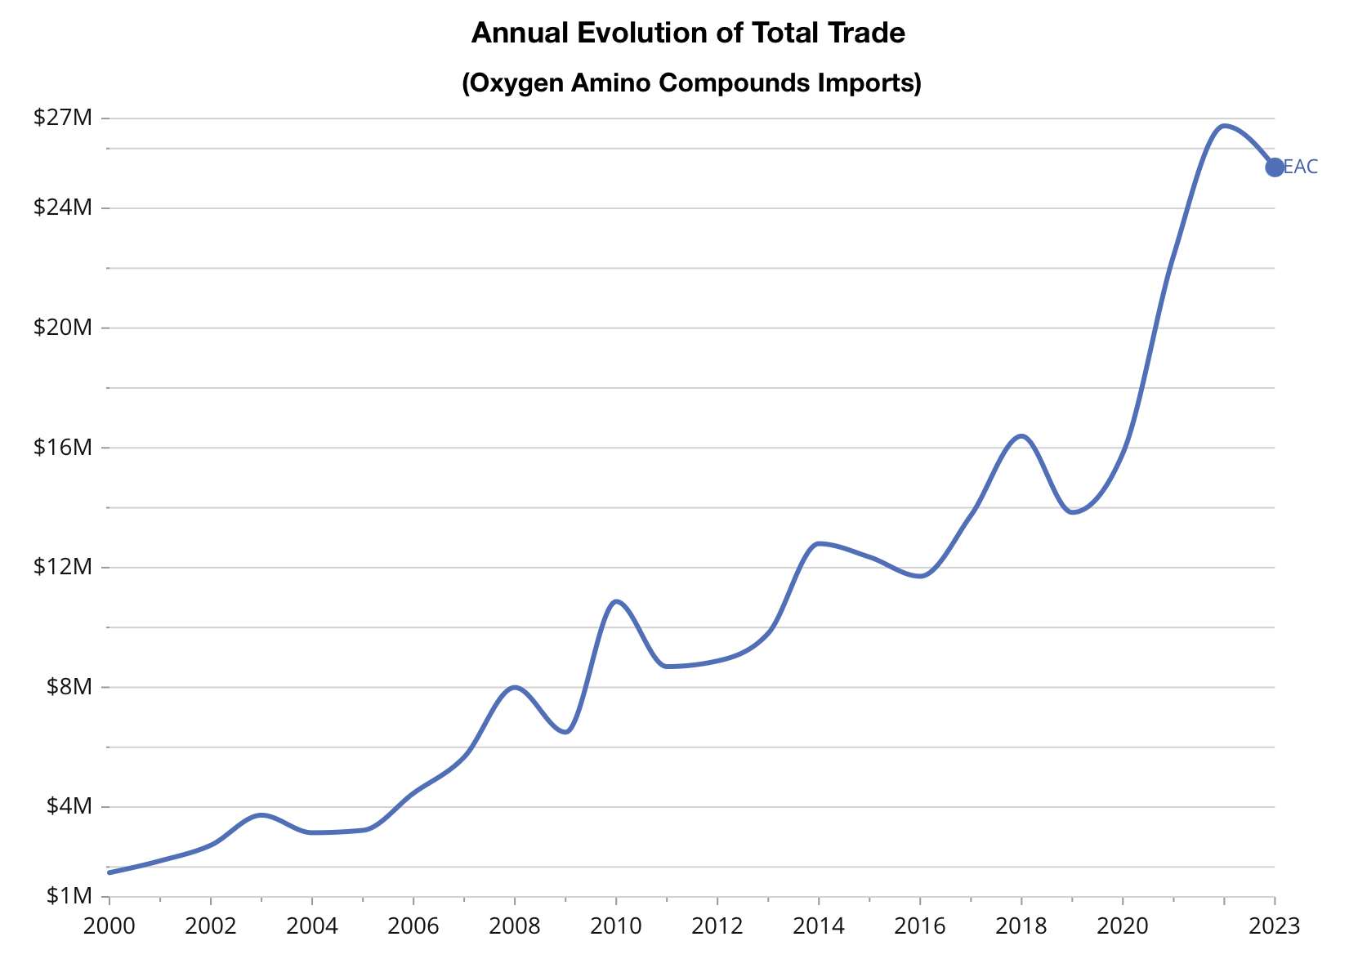

For Rwanda, the immediate entry point is glutamic acid and its salts (HS 292242), where exports grew 67% to US$433,000 in 2022 while imports rose 170%. This dual movement reflects a growing local consumption and external demand from neighbors such as Kenya, Uganda, and DRC. Establishing a reliable foothold in glutamates would allow Rwanda to build technical expertise and quality systems, and eventually expand into amino alcohols (HS 292219), a smaller but lucrative niche trading at US$30,000–70,000 per tonne.

**Investment and Capability Roadmap**

Rwanda’s entry into oxygen-function amino compounds should build on its current strength in glutamic acid. A pilot-scale facility, requiring US$2–5M, could expand production of glutamate and related amino acids while introducing basic amino alcohols using agricultural residues as feedstock. This first phase would build technical expertise, establish quality systems, and test commercial viability.

A second phase—scaling output to 50–100 t annually with an investment of US$15–25M—would supply regional pharmaceutical firms and meet WHO-GMP standards. Over time, this setup could evolve toward an integrated biorefinery producing 500–1,000t and supplying regional value chains.

Parallel infrastructure upgrades will be necessary. Expanding a 1 ktpa blending unit with bulk-packaging lines and ISO-certified laboratories would provide the backbone not only for HS 2922 but also for related lines such as HS 3506 (glues and adhesives) and HS 3208 (industrial paints).

These steps align with Vision 2050 goals and recent investments such as the [US$150M BioNTech mRNA facility (2024)](https://www.healthcaremea.com/biontechs-rwanda-commitment-paves-way-for-african-vaccine-equity) and the [African Development Fund’s US$12M pharmaceutical technology transfer program (2023)](https://afdb.africa-newsroom.com/press/rwanda-the-african-development-fund-commits-12-million-to-the-rapid-operationalization-of-the-african-pharmaceutical-technology-foundation-aptf).

**Benchmark Case**

[Ethiopia’s pharmaceutical park](https://www.fanamc.com/english/ethiopia-sets-to-boost-local-pharmaceuticals-industry-market-share-to-47-percent) increased local drug output from 36% to 47% of domestic demand through tax incentives and dedicated infrastructure, though it still relies on imported APIs. [Ghana’s US$321M pharmaceutical park](https://assets.kpmg.com/content/dam/kpmg/gh/pdf/KPMG%20site-selection-subsaharan-africa-life-sciences.pdf), complete with [WHO-GMP-certified laboratories](https://adphealth.org/upload/resource/Ghana_Local_Pharma_Production.pdf), has begun exporting active ingredients to neighbouring markets. [Morocco’s US$20B chemical sector](https://www.policycenter.ma/sites/default/files/2022-04/PP_07-22_Amachraa-Quelin_1.pdf)—integrated with European value chains—demonstrates how clustering raw materials, synthesis units, and downstream users can drive scale and competitiveness.

### 

### [Flagship 5: HS 3922 – Plastic Wash Basins](https://oec.world/en/profile/bilateral-product/plastic-wash-basins/reporter/rwa)

**Cluster:** Adjacent Growth Opportunities

|  |  |  |  |  |  |
| --- | --- | --- | --- | --- | --- |
| **PCI** | **Rel Relat** | **E&MA imports (US$M)** | **Entry SKUs** | **Key QA / certification** | **Supply gaps Rwanda can target** |
| 0.55 | +0.17 | 51.6 | Standard basins; reinforced basins; premium finish variants | ISO 9001; mold QA; durability testing | Mid-tier household basins; higher-spec items for EAC markets |

**Opportunity Overview**

Plastic wash basins are a fast-growing, mid-tech product with strong regional demand and clear feasibility for Rwanda. Imports into Eastern and Middle Africa reached US$51.6M in 2023, an increase of 20.7% over the previous year and almost 50% above 2018 levels, equivalent to an annual growth rate of 8.1%. With a PCI of 0.55 and positive relatedness of 0.17, basins sit just above Rwanda’s current productive frontier. Rwanda already shows a revealed comparative advantage of 0.55, indicating above-average specialization relative to economies of similar scale.

This combination of early specialization, rising regional demand, and manageable technological requirements makes HS 3922 a strong candidate for expanding local plastics capabilities. Developing production would substitute imports and create an entry point into broader polymer-processing, with natural links to adjacent products such as adhesives (HS 3506) and paints (HS 3208).

**Current Foundations**

A dozen firms form the backbone of Rwanda’s plastics sector. [EcoPlastic Rwanda](https://ecoplasticrwanda.com) transforms post-consumer waste into new products, while multiple companies specialize in pipes, bottles and fittings. [Mironko Plastic Industries](https://www.tradeindia.com/mironko-plastic-industries-ltd-11046506/) and [SWAN Hydrosol Ltd](https://www.rwandayp.com/company/3178/SWAN_HYDROSOL_LTD#google_vignette) supply household goods and water-storage tanks, and [Depot Kalisimbi Ltd](https://depotkalisimbi.org) innovates with construction materials made from recycled plastics. However, Rwanda lacks local polypropylene and polycarbonate pellet production, high-precision molds made with P20 steel or better, and operators trained in injection molding and thermoforming. These gaps must be closed to enable full-scale basin manufacturing.

**Market and Competitiveness Opportunity**

|  |  |  |  |  |
| --- | --- | --- | --- | --- |
| **Top importers (E&MA, 2023)** | **Value (US$M)** | **Fastest-growing (2018–2023, CAGR)** | **CAGR** | **Price range (US$/t, P10 / P50 / P90)** |
| Ethiopia | 6.5 | Eritrea | 84.1% | 864 / 4,678 / 10,041 |
| Kenya | 5.9 | Chad | 40.9% |
| Tanzania | 5.7 | Rep. of the Congo | 32.2% |

Regional demand for plastic wash basins is concentrated and expanding. In 2023, the leading importers were Ethiopia (US$6.51M), Kenya (US$5.85M), Tanzania (US$5.73M), the DRC (US$5.15M), and Cameroon (US$3.64M). Supply was led by China with US$26.64M, or 51.6% of the market, followed by Kenya (US$4.01M), India (US$3.71M), the UAE (US$3.07M), and South Africa (US$1.62M).

Prices follow a clear two-tier pattern. Weighted averages in 2023 were US$3,390 per tonne in Eastern Africa and US$2,195 per tonne in Middle Africa. Shipment-level prices ranged widely, with a median of US$4,678 per tonne and a P10 to P90 span of US$864 to US$10,041 per tonne. This reflects the coexistence of low-cost commodity lines and higher-spec branded products. The structure supports a tiered strategy that combines standard basins for high-volume markets with upgraded variants that compete on finish, durability, and certifications.

Within the East African Community, imports reached US$23.5M in 2023. Kenya, Tanzania, and the DRC accounted for about US$5 to 6M each, equal to 70% of bloc demand. Between 2018 and 2023, these three markets absorbed more than 65% of cumulative imports, with Kenya at US$30.5M, Tanzania at US$21.7M, and the DRC at US$20.4M. Rwanda (US$11.3M) and Uganda (US$10.8M) formed a strong secondary tier, while Burundi, Somalia, and South Sudan remained smaller but growing markets.

This geography highlights Rwanda’s dual position. The country can reduce its own import bill while capturing nearby demand in the DRC and Uganda, and can gradually build scale to compete with established suppliers in Kenya and Tanzania.

East African Community (EAC) Imports of Plastic Wash Basins

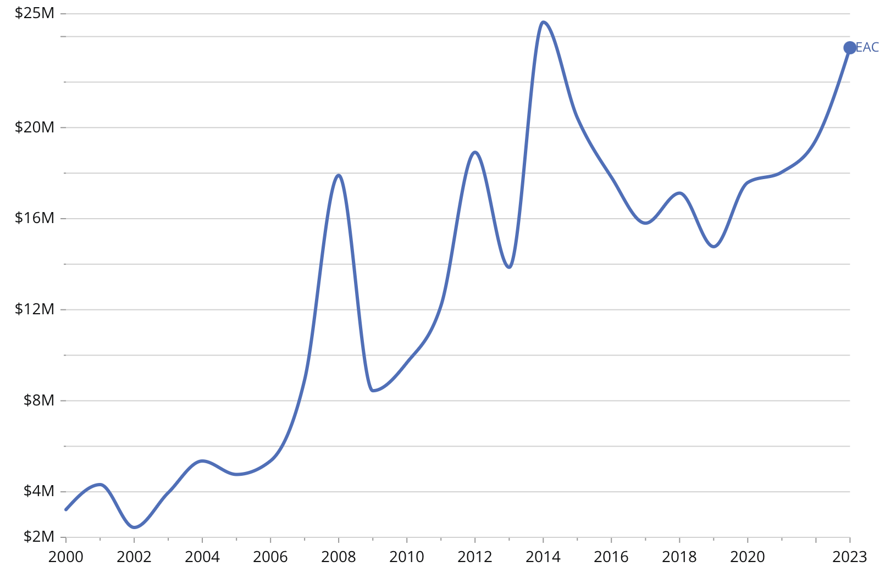

**Investment and Capability Roadmap**

In the first 12 months, a US$500,000–750,000 pilot plant—featuring a 450-ton injection-molding press, P20-steel molds and a basic QC station—can churn out 1,000–2,000 basins per month. In the next 12–24 months, adding two to three presses, automating cooling and drying lines, and upgrading the QC lab to ISO 9001 standards (US$1–2M) will boost capacity to 5,000–10,000 units monthly. By year three, a US$5–8M investment in additional presses, robotics and in-house pellet recycling capacities can drive output beyond 20,000 units per month, embedding circular-economy practices and driving down unit costs.

**Benchmark Case**

[Kenya’s Gjenge Makers](https://www.gjenge.co.ke) began as a small pilot scaling mixed-plastic recycling into paving bricks and wash basins, quickly hitting 1,000 tpa and securing county government contracts. In Tanzania, local producers leveraged modern injection-molding machines and [Dar es Salaam’s port](https://dailynews.co.tz/dar-port-emerges-as-africas-new-trade-titan/) to reach 1.4M basin units annually and US$599,000 in exports by 2023. Their success shows how aligning pilot investments with regional demand and local champions de-risks expansion and lays the foundation for sustainable, complexity-driven growth in Rwanda.

### [Flagship 6: HS 9018 – Medical Instruments](https://oec.world/en/profile/bilateral-product/medical-instruments/reporter/rwa)

**Cluster: Strategic Innovation Bets**

|  |  |  |  |  |  |
| --- | --- | --- | --- | --- | --- |
| PCI | Rel Relat | E&MA imports (US$M) | Entry SKUs | Key QA / certification | Supply gaps Rwanda can target |
| 0.89 | −0.52 | 658 | Thermometers; BP monitors; basic diagnostic devices; simple surgical instruments | ISO 13485; ISO 17025; WHO prequalification | Mid-range diagnostic kits; calibrated basic devices; regional hospital supply gaps |

**Opportunity Overview**

Medical instruments are one of the most dynamic opportunities in Rwanda’s diversification agenda. In 2023, Rwanda imported US$18M of HS 9018 products, a modest 2.1% decline from 2022. Across Africa, the medical devices market reached US$2.85B in 2023 and is expected to grow 7.1% annually through 2032. The global contract manufacturing market for medical devices already exceeds US$2.9B and is expanding at close to 10% per year.

For Rwanda, the sector aligns with strategic priorities: hospital network expansion, the pursuit of universal health coverage under Vision 2050, and the goal of building a high-skill, knowledge-intensive industrial base. With a PCI of 0.89, medical instruments sit well above Rwanda’s current ECI of 0.45 and represent a feasible but transformative entry point. Establishing assembly and calibration capabilities would reduce import dependence and position Rwanda within regional supply chains for advanced healthcare technologies.

**Current Foundations**

Rwanda lacks domestic production of medical instruments but has built critical adjacent capacities. The [Rwanda Standards Board](https://www.rsb.gov.rw) hosts ISO 17025–accredited laboratories, while the [Rwanda Biomedical Center](https://www.rbc.gov.rw) manages diagnostic and calibration facilities for public-health programs. [The University of Rwanda’s College of Science and Technology](https://cst.ur.ac.rw) trains biomedical engineers and technicians, and several private firms maintain hospital equipment. Together, these assets provide the technical and institutional base needed to convert an existing quality-assurance laboratory into a clean-room workshop equipped with autoclaves, torque benches, and calibration rigs. This would give Rwanda its first end-to-end platform for device assembly and testing.

ISO 13485 requires dedicated clean-room zones with controlled air quality, restricted access, and validated sterilization procedures. These conditions exclude co-location with chemical handling or plastics processing and set the operational boundary for regulated manufacturing.

A clean-room platform would extend the quality infrastructure developed through earlier flagships such as amino compounds (HS 2922), adhesives (HS 3506), and paints (HS 3208), and apply it to healthcare, strengthening Rwanda’s progression into precision manufacturing.

**Market and Competitiveness Opportunity**

|  |  |  |  |  |
| --- | --- | --- | --- | --- |
| **Top importers (E&MA, 2023)** | **Value (US$M)** | **Fastest-growing importers (2018–2023, CAGR)** | **CAGR** | **Price range (US$/t, P10 / P50 / P90)** |
| Angola | 119.0 | Chad | 35.1% | 5,000 / 25,600 / 100,000+ |
| Ethiopia | 84.0 | South Sudan | 25.3% |
| Tanzania | 83.0 | Equatorial Guinea | 22.8% |  |

The regional market for HS 9018 medical instruments is large and segmented. In 2023, Eastern and Middle Africa imported US$658M and 43,685t, with compound growth of 7.6% since 2018. Conditions diverged last year: demand eased in Eastern Africa but remained resilient in Middle Africa.

Imports are concentrated in Kenya, Tanzania, and Uganda, with significant demand in the DRC, Cameroon, and Angola. Two distinct segments drive the market. The first is bulk diagnostic kits and basic devices priced at US$5,000 to US$10,000 per tonne. The second is high-spec instruments, including surgical equipment and portable imaging devices, that exceed US$100,000 per tonne. In 2023, the median shipment was US$25,600 per tonne, and top-end prices surpassed US$1.3M, reflecting the coexistence of commodity and premium products.

Within the East African Community, imports reached US$283M in 2023, an increase of 30.3% over five years. Demand has trended upward since 2000 with only brief interruptions during global crises. Capturing even a small share of this market would position Rwanda within a high-complexity manufacturing segment.

East African Community (EAC) Imports of Medical Instruments

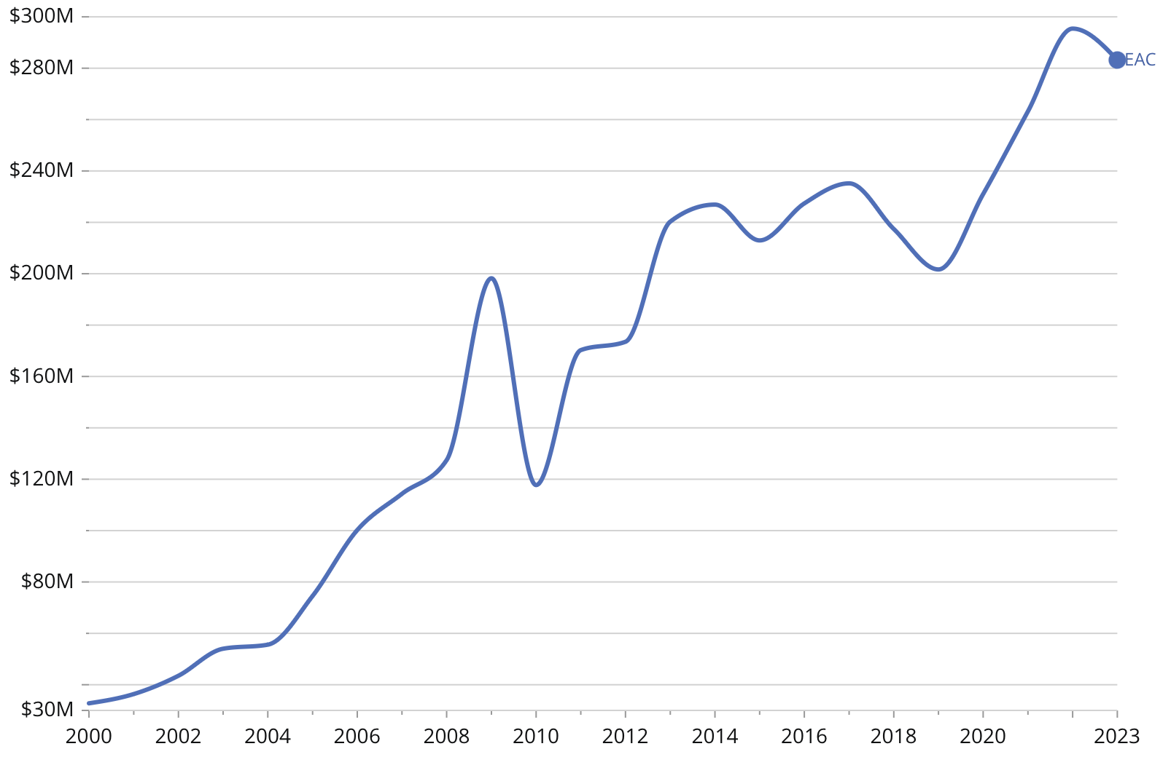

Supply is moderately concentrated: China, India, and European exporters dominate, while South Africa and the UAE act as regional hubs. The top four suppliers control just over half the market, leaving scope for reliable regional entrants. Rwanda’s role as host of the [African Medicines Agency](https://www.nepad.org/microsite/african-medicines-agency-ama) positions it advantageously, providing regulatory credibility and a platform to compete on quality and compliance.

**Investment and Capability Roadmap**

Rwanda’s pathway into medical instruments requires a phased approach that builds technical capacity while validating market demand. The first stage can convert part of an existing ISO-accredited laboratory into a clean-room workshop with sterilization autoclaves, torque-testing benches, and precision calibration rigs. With an investment of US$1 to 2M, this setup could produce and calibrate up to 50,000 basic devices per year, including thermometers and blood-pressure monitors, while training an initial group of 10 to 15 biomedical technicians.

A second stage, expected within 12 to 24 months, would add surface-mount technology lines, environmental stress chambers, and advanced test benches. This expansion, requiring an additional US$3 to 5M, would double production capacity and allow Rwanda to work toward WHO pre-qualification, which is essential for larger procurement markets.

By the third year, Rwanda could advance to contract manufacturing by integrating robotic assembly cells and design software, an upgrade costing US$5 to 8M. At this point, domestic firms would be able to supply regional hospitals and serve global equipment manufacturers that outsource assembly and calibration.

**Benchmark Case**

Kenya offers a relevant precedent. In 2022, [MedSource Labs](https://www.datacuberesearch.com/kenya-medical-device-market) partnered with GE Healthcare to assemble and calibrate ultrasound probes locally, cutting import costs by 25% and providing same-day technical support for hospitals. [South Africa](https://www.iej.org.za/wp-content/uploads/2022/11/IEJ-LoMMiA-report_Nov2022.pdf) shows the role of procurement policy. Hospital-tender frameworks there reserve a portion of contracts for domestically assembled devices, which creates predictable demand and sustains manufacturing capacity.

These cases point to two levers Rwanda can adapt. Partnerships with global equipment manufacturers can transfer technical know-how and provide certification credibility. Public procurement can anchor early demand and help new assembly lines reach scale. Combined, these approaches would allow Rwanda to replace imported HS 9018 products and position itself as a regional hub for medical-instrument assembly and calibration.

### [Flagship 7: HS 8538 – Electrical Power Accessories](https://oec.world/en/profile/bilateral-product/electrical-power-accessories/reporter/rwa)

**Cluster:** Strategic Innovation Bets

|  |  |  |  |  |  |
| --- | --- | --- | --- | --- | --- |
| **PCI** | **Rel Relat** | **E&MA imports (US$M)** | **Entry SKUs** | **Key QA / certification** | **Supply gaps Rwanda can target** |
| 0.99 | −0.25 | 109.8 | Stamped metal housings; connectors; terminals; small power-distribution accessories | ISO 9001; ISO 17025 electrical calibration; plating QA | Mid-tier accessories for Ethiopia/Kenya; premium components for Angola/DRC |

**Opportunity Overview**

Rwanda expanded its exports of power-distribution accessories from US$47,000 in 2021 to US$690,000 in 2022, but domestic demand still outpaced supply. Imports reached almost US$3M in 2022, showing a clear production gap. By 2023, East African buyers imported US$109.8M of HS 8538, reflecting the scale and variety of components sourced from abroad. As the region’s power grid grows from 21 GW to almost 29 GW by 2033, utilities and contractors will require more distribution hardware. If Rwanda builds capacity in this segment, it can narrow its trade imbalance and create an entry point into higher-value electronics assembly.

**Current Foundations**

Rwanda’s hardware ecosystem is led by firms such as [SOLEKTRA Rwanda](https://solektra.rw), which assembles solar-kits and distribution components, and [Quincaillerie Beta Ltd](https://quincailleriebeta.com), a regional supplier of electrical materials. Brilltech Engineers and [SOFARU Hardware](https://sofarultd.com) import and distribute panel boards, cables and connectors. Despite this base and ISO 17025–accredited calibration labs at the Rwanda Standards Board, no plant currently forges housings, stamps metal contacts, or carries out electroplating and high-precision assembly. Retrofitting a single workshop bay with a 200-ton stamping press, plating line, and torque-testing stations can establish Rwanda as a small producer of power accessories.

**Market and Competitiveness Opportunity**

|  |  |  |  |  |
| --- | --- | --- | --- | --- |
| **Top importers (E&MA, 2023)** | **Value (US$M)** | **Fastest-growing (2018–2023, CAGR)** | **CAGR** | **Price range (US$/t, P10 / P50 / P90)** |
| Angola | 15.2 | Djibouti | 21.5% | 8,830 / 18,200 / 20,000+ |
| Ethiopia | 12.0 | Somalia | 19.8% |
| DR Congo | 11.4 | DR Congo | 13.7% |

In 2023, Eastern and Middle Africa imported US$109.8M of electrical power accessories, an increase of 13.4% from 2022. Eastern Africa accounted for US$61.1M at an average price of US$8,830 per tonne, while Middle Africa imported US$48.8M at US$18,200 per tonne. This gap reflects two tiers: bulk lower-value goods in Eastern Africa and higher-spec consignments in Middle Africa. After contractions in 2019 and 2020, demand has recovered, with Middle Africa driving much of the recent growth.

Angola illustrates the premium segment. Imports reached US$15.2M in 2023 at more than US$20,000 per tonne, combining bulk shipments from China and Portugal with high-value consignments from Bahrain, Germany, the United Kingdom, and South Africa. Ethiopia illustrates the volume-driven tier. Imports rose almost 59% in 2023 to US$12M and 1,600t, dominated by Chinese mid-tier products with occasional premium shipments from Bahrain and Germany. Djibouti’s function as a re-export hub for low-priced, high-volume goods shows how corridor logistics shape competition in inland markets.

Imports of Electrical Power Accessories by Origin (2023)

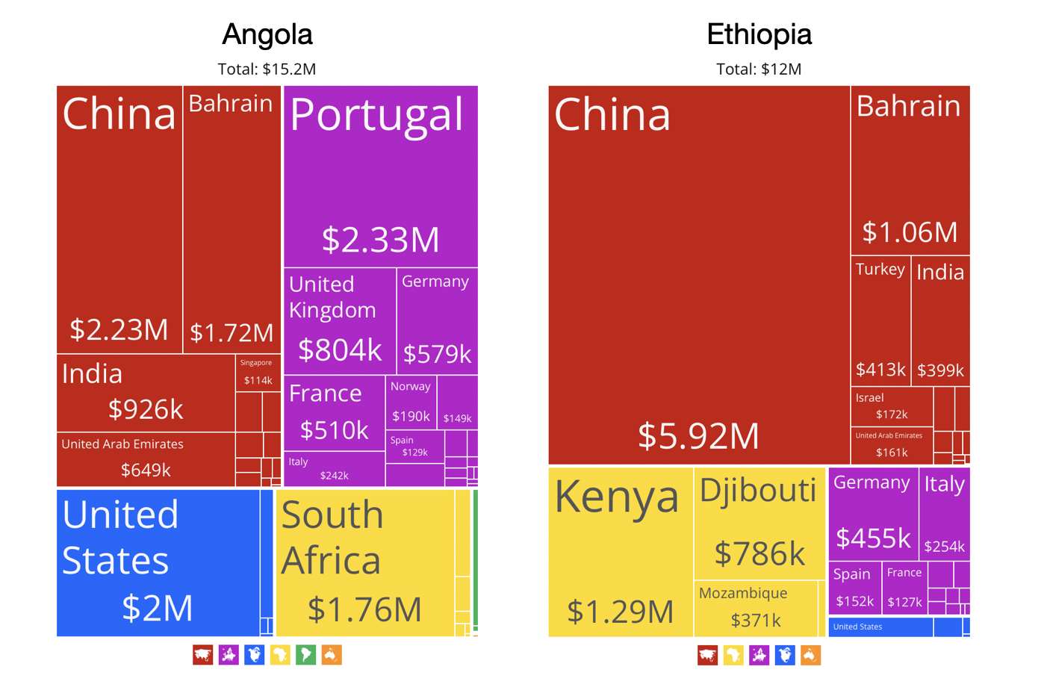

For Rwanda, these dynamics support a two-track strategy. Cost-efficient production can supply Eastern Africa’s mid-price markets, particularly Ethiopia, Kenya, and Tanzania. Certified higher-value accessories can target Angola, the DRC, and Cameroon, where utilities and industrial projects pay premiums for quality and reliability. With Africa importing more than 90% of its power accessories, Rwanda can pair domestic import substitution with selective export entry to build a position in both the mid-price and premium tiers.

**Investment and Capability Roadmap**

A sequenced upgrade path is feasible. A pilot investment of US$0.8–1.2M would outfit a workshop with stamping, plating, and torque-testing equipment, enabling 100,000–200,000 units annually. A second phase, at US$2–3M, would expand plating capacity, add CNC trimming machines, and extend clean-room assembly, lifting output to 500,000 units. In the industrial scale phase, US$5–7M could fund robotic handling, automated inspection, and polymer overmolding, raising capacity beyond one million units a year. Importantly, this pathway reuses quality and calibration infrastructure already being built for medical instruments and specialty chemicals, allowing shared use of quality and calibration infrastructure with other products.

**Benchmark Case**

In 2023, [ACTOM Group](https://actom.co.za/default.aspx) acquired Schneider Electric’s low-voltage assembly plant in Nairobi and expanded it into a regional production site. Within two years, it cut Kenya’s import bill for distribution accessories by 30% and secured major contracts with utilities and OEMs. This model combines international technology transfer with local manufacturing scale, supported by strong quality controls and efficient logistics. Rwanda can adapt this approach on a smaller scale by partnering with an established OEM, embedding calibration and plating capacity within Kigali’s SEZ, and targeting both domestic substitution and regional exports. Under this approach, HS 8538 could become Rwanda’s entry point into higher-value electronics and contribute to the targeted 5% uplift in ECI.

### 

### [Flagship 8: HS 8473 – Office Machine Parts](https://oec.world/en/profile/bilateral-product/office-machine-parts/reporter/rwa)

**Cluster: Strategic Innovation Bets**

|  |  |  |  |  |  |
| --- | --- | --- | --- | --- | --- |
| **PCI** | **Rel Relat** | **E&MA imports (US$M)** | **Entry SKUs** | **Key QA / certification** | **Supply gaps Rwanda can target** |
| 0.99 | −1.06 | 400 | Chassis parts; rollers; gears; small precision components | ISO 9001; ISO 17025 calibration; precision metrology | Mid-range parts for Ethiopia/Kenya; specialty components for high-value Angola segment |

**Opportunity Review**

Office-machine parts such as chassis, gears, rollers, and precision components for printers, copiers, and calculators serve a growing regional market. In 2023, Eastern and Middle Africa imported US$400M of HS 8473, equal to 14,700t, at an average price of US$27,200 per tonne. Trade has grown 3.6% annually since 2018, despite mid-period volatility, and remains a key input for Africa’s expanding digital and office economies. Eastern Africa accounts for 67% of demand, or US$268M, while Middle Africa accounts for US$132M with higher unit values.

For Rwanda, this product sits near the upper limit of feasible industrial entry. With a PCI of 0.99, HS 8473 is among the most knowledge-intensive items in the diversification portfolio and is significantly above Rwanda’s current ECI of 0.45. Securing even a small share of this US$400M market would represent Rwanda’s move into precision manufacturing and provide a platform for future electronics assembly.

**Current Foundations**

Rwanda’s machining ecosystem remains small but evolving. Local workshops in Kigali’s industrial zones produce automotive and electrical parts using basic CNC tools. ISO 17025–accredited labs at the Rwanda Standards Board and the Rwanda Biomedical Center provide calibration capacity, while firms like [Brilltech Engineers](https://www.brilltech.co.in/rwanda/electric-cables.htm) operate CNC units for enclosures and panels. Yet no domestic facility produces to the ±5 μm tolerances or applies the advanced surface finishing (passivation, electropolishing) required for office-machine components. Retrofitting an SEZ workshop with a 3-axis CNC center, precision broaching, and automated inspection rigs could shift Rwanda from general metalwork toward precision parts manufacturing.

**Market and Competitiveness Opportunity**

|  |  |  |  |  |
| --- | --- | --- | --- | --- |
| **Top importers (E&MA, 2023)** | **Value (US$M)** | **Fastest-growing (2018–2023, CAGR)** | **CAGR** | **Price range (US$/t, P10 / P50 / P90)** |
| Ethiopia | 47.0 | Gabon | 34.8% | 200 / 41,000 / 1,000,000+ |
| Angola | 45.0 | Ethiopia | 31.4% |
| Kenya | 44.0 | Cameroon | 16.8% |

The regional market for office-machine parts is large and clearly segmented. In 2023, Ethiopia (US$47M), Angola (US$45M), and Kenya (US$44M) were the largest importers, followed by Tanzania and Mozambique at about US$37M each. These five markets account for nearly half of Eastern and Middle Africa’s US$400M demand. Trade divides into two tiers: bulk commodity parts priced between US$6,000 and US$20,000 per tonne, and high-precision components that exceed US$100,000 per tonne. The median shipment reached US$41,000 per tonne, with extremes ranging from US$200 per tonne for bulk consignments to more than US$1M per tonne for specialized modules. This confirms the coexistence of commodity and premium niches.

Rwanda’s position reflects this structure. The country imported US$9M in 2023, equal to 175t at an average price of US$51,000 per tonne, sourcing mainly from the UAE (US$3.8M), China (US$1.6M), and the Netherlands (US$1M). This unit value sits well above the regional weighted average of about US$25,000 to US$28,000 per tonne, which signals concentration in higher-spec products. Exports remain small at US$35,000 but suggest early activity in re-exports or light processing. Across the continent, imports exceeded US$2B, led by South Africa (US$686M), Morocco (US$187M), and Egypt (US$172M).

Imports of Office Machine Parts (2023)

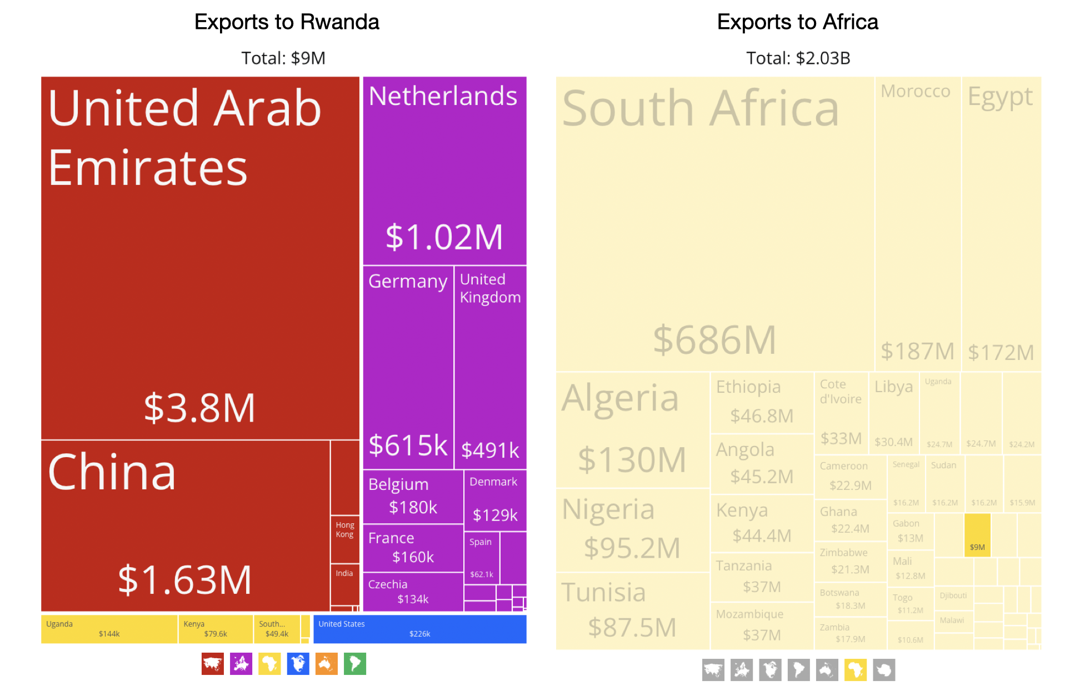

**Investment and Capability Roadmap**

Rwanda’s pathway into office-machine parts starts with a focused pilot that builds precision capability in stages. The first phase requires an investment of about US$1 to 1.5M to install a 3-axis CNC machine, broaching tools, and an automated optical-inspection station in the Kigali SEZ. This equipment could produce roughly 50,000 precision parts per year, supplying local distributors and maintenance firms while demonstrating Rwanda’s ability to manufacture at tighter tolerances.

The second phase, expected within 12 to 24 months, would add a 5-axis CNC center, robotic handling equipment, and a passivation line at an additional cost of US$2 to 3M. These upgrades would double annual capacity to about 100,000 parts and allow Rwanda to meet micrometer-level tolerances required for higher-value contracts.

A third phase, with an investment of US$5 to 7M, would bring clean-room assembly booths, laser-marking systems, and small grinding cells. At this stage, annual output would exceed 200,000 units and position Rwanda to supply regional markets under AfCFTA while establishing a foothold in high-precision manufacturing.

**Benchmark Case**

In November 2023, French manufacturer [**Exxelia**](https://exxelia.com/en/news/inauguration-exxelia-manufacturing-site-morocco) opened a 10,000 square metre electronics plant in Mohammedia, Morocco, which includes a 200 square metre clean-room and Industry 4.0 processes for high-reliability modules. The facility shows that clean-room assembly and certified quality systems can operate competitively in Africa while supplying global original equipment manufacturers. Tunisia provides a second precedent. Its established electronics manufacturing services cluster exports sub-assemblies and finished electronics to Europe, and the national industry registry lists about 340 firms with more than 10 employees in electric and electronic manufacturing, which highlights the sector’s depth.

These cases show that Africa can sustain advanced electronics manufacturing and integrate into global value chains. For Rwanda, adapting this model by pairing CNC machining and calibration with AfCFTA-enabled regional exports can reduce the country’s high import bill for office-machine parts and create a viable foothold in precision manufacturing. This path is consistent with the projected 4.9% ECI growth contribution.

## 

## How the Portfolio Works Together

The model relies on shared assets and knowledge that move across sectors. Practices first established in chemical blending, including ISO-accredited quality control, solvent handling, and batch traceability, spread horizontally into paints, adhesives, and fragrances. Once these standards are embedded in Rwanda’s testing labs and regulatory agencies, plastics processors can adopt them for extrusion and molding. The precision requirements developed in plastics and coatings then carry into clean-room assembly for medical devices and power accessories, establishing common routines for measurement, calibration, and certification.

These capabilities flow through firms, training institutions, and standards bodies. Universities add technical modules as industry requirements shift, regulators broaden accreditation schemes, and suppliers raise product quality to meet buyer expectations. Once a capability is established in one part of the portfolio, it can be reused elsewhere, reducing learning times, avoiding duplication, and supporting the transition from bulk processing to higher-precision manufacturing.

Financing follows the same sequence. Early gains in chemicals justify donor grants and SME lending for blending units. Mid-tech investments in plastics and paints attract private capital because cash flows are predictable. High-risk pilots in medical devices and machine parts become investable only after earlier stages reduce technology-transfer risk and show that Rwanda can regulate and certify production. Within AfCFTA’s tariff schedule and the EAC’s trade corridors, blended finance instruments can increase in size as the industrial base matures.

The result is an industrial portfolio in which each flagship reinforces the next. Chemicals support plastics, plastics anchor coatings, coatings lead to clean-room assembly, and clean-rooms open pathways into electronics and medical devices. Each layer raises the value of prior investments in equipment, standards, and skills. This portfolio approach allows Rwanda to increase its complexity by linking projects so that each step builds capabilities that strengthen the entire system.



# 

# 

# 

# 

# 

# 

# 

# Chapter 3

# Making It Happen

# Chapter 3

# Making It Happen

Implementing this strategy requires more than selecting products. Rwanda must run an execution system across the whole investment cycle, mobilizing blended capital through the Rwanda Development Guiding Fund, fast-tracking strategic projects via a fast-lane regulatory pathway, embedding technical expertise through an Open Economy for Knowledge Workers, and enforcing accountability through a real-time industrial delivery system.

### Rwanda Development Guiding Fund

One lesson from China’s industrial ascent is the role of guiding funds, blended public–private vehicles that crowd in capital for priority industries without distorting markets. Zhongguancun, often called “China’s Silicon Valley,” was not built through subsidies or showcase factories, but through disciplined funds that signaled national priorities, shared risks transparently, and attracted sophisticated investors. This model showed that patient, risk-sharing capital can accelerate capability building while keeping market incentives intact.[1]

In Rwanda, the Rwanda Development Guiding Fund serves the same purpose. It operates as a permanent blended-capital platform that pools public and private resources on pari passu terms. Government seed capital shares upside and downside equally with private investors. Anchored by the BRD and the RDB, the fund aims to mobilize US$100 to 150 million by combining US$50 million of public seed financing with contributions from development partners, diaspora bonds, and private investors. By targeting mid-sized industrial projects requiring between US$2 million and US$20 million, the RDGF fills a critical financing gap where promising ventures often stall between pilot and scale.

Governance arrangements are central to the fund’s credibility. An independent investment committee staffed with financial professionals would operate at arm’s length from day-to-day politics and remain accountable to a private-sector advisory council. Government contributions would be repaid at cost plus a capped premium, which maintains fiscal discipline and allocates most upside to investors. The RDGF is therefore a structured equity vehicle designed to align incentives and crowd in private capital, not a subsidy instrument.

The RDGF mandate is to strengthen industrial investment while avoiding future fiscal pressure. The fund’s design reflects this requirement. Government participation is capped at a predetermined share of each transaction, and public seed capital is deployed only on pari passu terms with private investors. Portfolio-level risk controls limit the Treasury’s maximum exposure and prevent public capital from absorbing open-ended downside risk. As investments mature, government returns are recycled to preserve the fund’s capital base rather than create new recurrent obligations. This structure keeps the instrument fiscally neutral while allowing private investors to remain the principal drivers of project selection, risk assessment, and scale-up.

Rwanda’s own experience shows the feasibility of this model. The Rwanda Innovation Fund mobilized private investment in high-risk tech SMEs through structured guarantees backed by the AfDB. BRD’s growth facilities unlocked US$30 million in SME lending by reducing bank-level credit risk. The Export Growth Fund blended concessional credit with partial guarantees to help firms expand production and reach new markets. Yet each initiative has been debt-focused, sector-specific, or temporary. None created a systemic, equity-style mechanism to finance industrial upgrading at scale. The RDGF fills that gap.

Other African precedents confirm that this approach is viable. South Africa’s Industrial Development Corporation has long used equity, quasi-equity, debt, and guarantees to support industrialization while maintaining commercial discipline. In Morocco, the Fonds Mohammed VI pour l’Investissement operates as a public-private investment platform that directs capital to strategic sectors through thematic and infrastructure-focused funds. These institutions show that blended-capital platforms in Africa can combine clear mandates, rigorous governance, and developmental objectives in ways that mirror the RDGF’s design.

The RDGF would extend this model in Rwanda by linking directly to the country’s complexity roadmap. Early wins in chemicals and adhesives justify follow-on grants and loans. Mid-tech investments in plastics and paints attract private investors because cash flows are predictable. High-value pilots in medical devices and machine parts become investable once early phases demonstrate Rwanda’s ability to regulate and certify production. In this way, the fund becomes the financial backbone of the industrial strategy rather than a standalone initiative.

A permanent guiding fund moves Rwanda beyond ad hoc programs and isolated guarantees. The RDGF turns strategic intent into investable projects and enables the eight flagship products and their clusters to scale from concept to competitive industries. If implemented effectively, it would position Rwanda as an early adopter of blended equity at scale in support of higher-complexity production.

### Open Economy for Knowledge Workers

Capital will not raise complexity without people who know how to build, certify, and export. Rwanda needs an open, targeted talent regime to execute the flagship products in chemicals, plastics, power accessories, medical instruments, and precision parts that anchor this strategy.

Rwanda already built part of this platform. Carnegie Mellon University Africa (CMU‑Africa) is a graduate campus in Kigali Innovation City that offers MS programs in information technology, electrical and computer engineering, and engineering AI. CMU‑Africa reports more than 320 students, over 870 alumni, and a 94% employment rate within one year of graduation. These cohorts supply engineers and data professionals who can staff quality labs, automation projects, and regulated production lines.

Rules exist for skilled entry. A [2022 ministerial order](https://www.migration.gov.rw/fileadmin/user_upload/pdf_files/ministerial_order_11_11_2022_1.pdf) establishes the Occupations in Demand List and sets procedures for labor‑market testing and classification. The order recognizes EAC Common Market provisions for liberalized occupations. Rwanda’s V4 Job‑Search visa lets foreign professionals whose skills appear on the list enter for up to 90 days while they secure employment. These instruments define a legal path for targeted technical recruitment.

Demand for experienced specialists is real. According to the [National Bank of Rwanda](https://www.bnr.rw/documents/FOREIGN_PRIVATE_CAPITAL_IN_RWANDA_2024.pdf), firms with foreign private capital employed 59,916 people in 2023, including 1,501 foreign specialists across short‑ and long‑term roles. This small but critical cohort helps commission plants, install quality systems, and train local teams.

To reduce hiring friction for technical roles, Rwanda should strengthen HEC’s foreign-degree equivalence system by setting a 10-day service level for evaluations, publishing monthly processing statistics, and expanding the list of pre-approved accredited institutions for priority occupations. Faster and more predictable decisions lower onboarding delays for engineers, chemists, and technicians in flagship industries.

Rwanda can now pull these pieces into a single, execution‑oriented framework:

1. **Critical Skills Track.** Publish an annual Occupations in Demand list aligned to the industrial portfolio and its HS codes. Establish a 10-day service-level agreement for permits and accreditation decisions for listed roles. Report quarterly metrics on approvals, rejections, and processing times.
2. **Kigali Skills Exchange.** Create a placement hub at CMU-Africa that matches firms in flagship product lines with graduate engineers and mid-career specialists. Require participating firms to submit training plans that pair each foreign hire with two Rwandan understudies. Track training completion and wage outcomes.
3. **Diaspora Technical Assignments.** Launch 6- to 18-month secondments for Rwandan professionals abroad to lead factory start-ups, certification audits, and automation retrofits. Use the Occupations in Demand channel for expedited processing and publish placement data linked to the flagship pipeline.
4. **Regulated‑industry anchors.** Tie fast-tracked talent to projects that expand Rwanda’s regulatory credibility. The Kigali [mRNA facility](https://www.reuters.com/business/healthcare-pharmaceuticals/biontech-wins-up-145-mln-cepi-support-african-mrna-vaccine-plants-2024-05-29/) shows how frontier production requires high-skill teams. Prioritize similar anchors in devices and specialty chemicals and link them to structured on-the-job training.
5. **Measurement.** Use the current count of 1,501 foreign specialists in FPC firms as the baseline. Track placement shares by sector, reduce permit times, and raise the ratio of certified technicians to total plant staff. Publish results on the same public dashboard that tracks investment and exports.
6. **HEC equivalence services**: Commit to a 10-day service level for foreign degree recognition, publish monthly metrics, and pre-approve equivalence for degrees from accredited institutions in priority occupations.

This design aligns Rwanda’s industrial plan with a defined talent pipeline. It builds on existing universities, immigration rules, and accredited laboratories, and then adds speed, transparency, and placement discipline. The result is faster learning by doing and a steeper trajectory up the capability ladder that underpins long-term competitiveness.

### Fast-Lane Regulation — Unblocking Projects in 120 Days

Rwanda can move strategic plants from commitment to commissioning within four months by converting today’s service charters and digital systems into a single, time‑bound approvals track. The baseline already favors speed. Rwanda ranks 38th globally on the [World Bank’s Doing Business](https://www.worldbank.org/content/dam/doingBusiness/country/r/rwanda/RWA.pdf) 2020 index, with seven days to register property, 30 days to obtain an electricity connection in the standard case, and a 97‑day benchmark to obtain a construction permit for a warehouse.The [Rwanda Development Board](https://rdb.rw/wp-content/uploads/2022/02/Investment-code-2021.pdf?utm_source=chatgpt.com) issues investment certificates within two working days under Article 12 of the 2021 Investment Code and its service charter, and company registration services are delivered within six working hours by the Office of the Registrar General. These are assets the fast‑lane should institutionalize.

The fast-lane would formalize a single project officer for each strategic investment. RDB already assigns focal persons to approved projects. Embedding this role into a 120-day pathway means the project officer triggers all required approvals on day zero, including environmental clearance, land and construction permit, utility connections, standards compliance, and customs facilitation. The approach does not create new procedures. It sequences existing ones in parallel and enforces the service-charter timelines already published by the government.

Environmental approvals set the critical path in many industrial projects. Current law and practice support predictable timelines. RDB’s service charter indicates 15 days for EIA clearance and 45 days for the EIA certificate once a complete file is submitted. [Recent guidance](https://rdb.rw/wp-content/uploads/2025/07/Service-Charter-EN-1.pdf) referencing Ministerial Order 001/2019 also indicates RDB should analyze a submitted EIA report within 20 working days, with an extra 15 working days when a public hearing is required. The fast‑lane should commit to those clocks, publish when the clock starts, and stop it only when the applicant is formally asked for additional information.

### Transparency & Accountability — Turning Strategy into a System

Industrial transformation requires disciplined execution. Rwanda has built strong performance systems through Imihigo contracts, the Rwanda Governance Scorecard, and structured monitoring of Vision 2020 and Vision 2050. These tools have strengthened coordination and accountability across ministries. Industrial upgrading adds new requirements because production, certification, skills, and investment decisions must move together for firms to scale.

Rwanda’s digital infrastructure provides the backbone for real-time monitoring. The [Irembo platform](https://www.irembo.gov.rw/public/), documented in the Digital Foundations section, has processed over 25 million applications through 7,000 agents, with transactions above US$300 million, reducing service times to under 24 hours. These capabilities demonstrate that Rwanda can manage high-volume, time-bound processes across agencies.

Although regulatory agencies use digital systems, firms still encounter fragmented workflows across standards, environmental approvals, utilities, and SEZ operations. Rwanda should gradually harmonize these platforms into a single approvals interface with shared case IDs, integrated document repositories, and synchronized service-charter timelines. A unified system reduces coordination costs and ensures that fast-lane projects move through all agencies with consistent processing.

To translate industrial strategy into delivery, Rwanda can formalize a Transparency & Accountability System for Industrial Policy. The system would track strategic projects and flagship products through four functions:

* Real-time dashboard consolidating permitting, land and utility connections, certification cycles, investment inflows, and export volumes. Data would flow from Irembo, RSB’s ISO-17025 labs, and SEZ systems already described in this report.
* Quarterly industrial reporting that publishes progress on production, jobs, and exports for adhesives (HS 3506), paints (HS 3208), plastics (HS 3922), brake fluid (HS 3819), medical instruments (HS 9018), and electrical accessories (HS 8538). This mirrors the evidence-based monitoring used in Vision 2050 and the 2024–2034 Industrial Policy.
* Performance compacts for agencies responsible for standards, permitting, and SEZ operations, modeled on Imihigo and linked to fast-lane regulatory privileges or budget disbursements.
* Independent verification reviews conducted with business associations and technical institutes, following global practice in structured delivery units.

Benchmark experience supports this model. Malaysia’s [PEMANDU](https://pemandu.org/) used weekly reporting, delivery labs, and open dashboards to accelerate reforms in priority sectors. Morocco’s [Industrial Acceleration Plan](https://www.mcinet.gov.ma) applied public scorecards to track progress of industrial ecosystems and guide investor decisions.

By making implementation visible and measurable, Rwanda can align capital, regulation, and skills across agencies. A transparent delivery system signals predictability to investors and ensures that industrial policy shifts from intent to operational performance.

### What Success Looks Like

Rwanda’s industrial transformation depends on measurable shifts in productive capacity, technological capability, and export composition. Success means new factories operating in priority sectors, firms creating high-quality industrial jobs, and a sustained rise in exports of more complex products that broaden the national knowledge base and strengthen Rwanda’s role in regional and global value chains.

A credible monitoring and evaluation framework should track how capabilities, production, and exports evolve across the flagship portfolio. Capability indicators include the number of ISO-accredited tests completed each quarter, the count of firms achieving ISO 9001 or ISO 13485 certification, and the pool of technicians trained in chemical processing, molding, and precision assembly. Production metrics should monitor annual output in strategic products, the share of inputs sourced regionally, and line-level defect rates, which together indicate whether firms are scaling and whether quality systems are maturing.

Export performance provides a complementary signal. Rising export values, stronger RCA in each flagship line, and growth in the number of EAC and AfCFTA markets reached will show whether new capabilities are translating into market presence. Regulatory performance must be monitored with equal discipline. Permit processing times, the share of strategic projects that meet the 120-day fast-lane benchmark, and adherence to published service-charter timelines will indicate whether the regulatory environment is enabling investment. Capital mobilization should also be tracked. The volume of financing deployed through the Rwanda Development Guiding Fund, the private-to-public leverage ratio, and the number of projects reaching commercial operation will show whether blended finance is functioning as intended.

Publishing these indicators on a quarterly dashboard will provide a consistent basis for assessing progress toward the targeted improvement in Rwanda’s Economic Complexity Index and will help identify bottlenecks early.

Operationally, success will appear as shorter approval timelines, faster integration of skilled technical workers into firms, and higher domestic value addition in adhesives, paints, plastics, and medical devices. Regular publication of data on investment flows, production volumes, job creation, and export outcomes will reinforce accountability and signal to investors that commitments are being delivered.

At the system level, Rwanda will succeed when capital mobilization, talent attraction, regulatory efficiency, and monitoring platforms operate as a single delivery mechanism. This alignment marks the shift from strategic planning to consistent execution. Internationally, Rwanda will be recognized not only as an investment-friendly location but as an emerging manufacturing hub capable of turning industrial policy into real diversification, technological upgrading, and inclusive growth.

## Conclusion & Next Steps

Rwanda’s industrial strategy sets a clear ambition to move from a narrow export base to a more sophisticated and technologically capable economy that creates high-quality jobs and sustained growth. The country already holds strong foundations, including a 2nd-place ranking in Africa and a 38th-place global ranking in the World Bank’s 2020 Doing Business Report. The next step requires disciplined execution built on data, coordination, and clear accountability.

The Rwanda Development Guiding Fund can mobilize blended capital for mid-sized manufacturing ventures. These ventures need a fast-lane regulatory track that clears strategic industrial projects in under 120 days. Firms also need reliable access to technical talent, which requires a national framework that integrates visa reform, diaspora placement, and targeted skills pipelines. Once projects begin operating, a real-time industrial dashboard should track jobs, exports, and investment flows so that policymakers and investors can monitor progress and identify bottlenecks.

Rwanda now needs to shift from individual reforms to system performance. The instruments already exist: capital, regulation, talent, and monitoring. Their impact depends on how tightly Rwanda aligns them. Financing without regulatory certainty leaves projects stuck. Rapid approvals without skilled workers reduce competitiveness. Talent programs without monitoring do not show results. Only a unified execution system can convert national strategy into delivery.

Success will depend on measurable outcomes. These include factories breaking ground on schedule, precision parts entering production, and exports rising in the trade data. For citizens, the proof will come through more high-quality jobs and broader opportunities to gain new skills. Execution will determine whether Rwanda’s industrial ambition produces sustained and inclusive growth.

## Reflections from Our October Mission to Kigali

From October 28 to November 2, 2024, Gilberto García and I (César A. Hidalgo) had the privilege of spending a week in Kigali. During that week, we worked directly with colleagues from the Ministry of Finance and Economic Planning, the Ministry of Trade and other agencies and partners coordinated by UNDP. Over two days of training and discussion sessions, we engaged with professionals whose dedication, clarity of purpose, and commitment to Rwanda’s future made a strong impression on us.

Beyond the formal program, our visit reinforced something that numbers alone cannot fully capture. Rwanda is a country that radiates order, responsibility, and a deep culture of accountability. These qualities are visible in Rwanda’s infrastructure, institutions, and the way people approach their work. These are not just admirable cultural traits, but strategic assets that will support the country’s transition into increasingly complex industries. The cleanliness of Kigali, the efficiency of its public services, and the professionalism of its institutions all speak to a society that is investing in the long run.

Amid this positive landscape, we also observed one important barrier whose impact is larger than what one might intuitively think: Kigali’s airport experience.

Singapore’s founding Prime Minister Lee Kuan Yew famously emphasized how deeply airports shape perceptions. He saw Changi not merely as transportation infrastructure but as a statement of national identity and ambition. He believed that the moment visitors stepped off a plane, they should immediately sense what the country stood for. This attention to first impressions was not cosmetic. It was part of a coherent development strategy to make Singapore a magnet for global talent and investment.

Rwanda aspires, and is well positioned, to play a similar role for Africa: a safe, efficient, and welcoming hub for regional and international knowledge workers. We believe that overtime Rwanda could become the Singapore of East Africa. And getting there required an airport experience that reflects this ambition and would reinforce the message that the country is open, modern, and oriented toward high-value industries.  
  
Kigali International Airport is secure and functional, yet the process of entering the airport grounds, requiring passengers to exit their vehicles for a full military-style inspection, creates an atmosphere of distrust that feels like the opposite of a welcoming gateway in an emerging knowledge hub. For knowledge workers, entrepreneurs, engineers, and investors who travel frequently in and out of the country, the first and last impression matters enormously. And because of Rwanda’s geography, these first and last impressions are bound to take place at Kigali’s international airport.

We do not propose a specific solution here—that is for Rwanda’s leadership to define. Rather, we highlight the issue as a strategic opportunity. A smoother, more welcoming airport experience would amplify all the strengths Rwanda already possesses and help the country compete not only in goods markets, as detailed in this report, but also in the global market for talent, ideas, and investment.

Our week in Kigali left us with a lasting sense of optimism. Rwanda has built the cultural, institutional, and infrastructural foundations that many countries take decades to establish. With continued focus and coordination, and by addressing small but high-impact bottlenecks such as the airport experience, Rwanda can position itself as one of Africa’s leading centers for capability-driven growth.

We are immensely grateful for the hospitality extended to us, for the openness of the discussions, and for the privilege of contributing to Rwanda’s ongoing transformation. We look forward to deepening this collaboration in the years to come.

# Appendix

## SECTION GLOSSARY

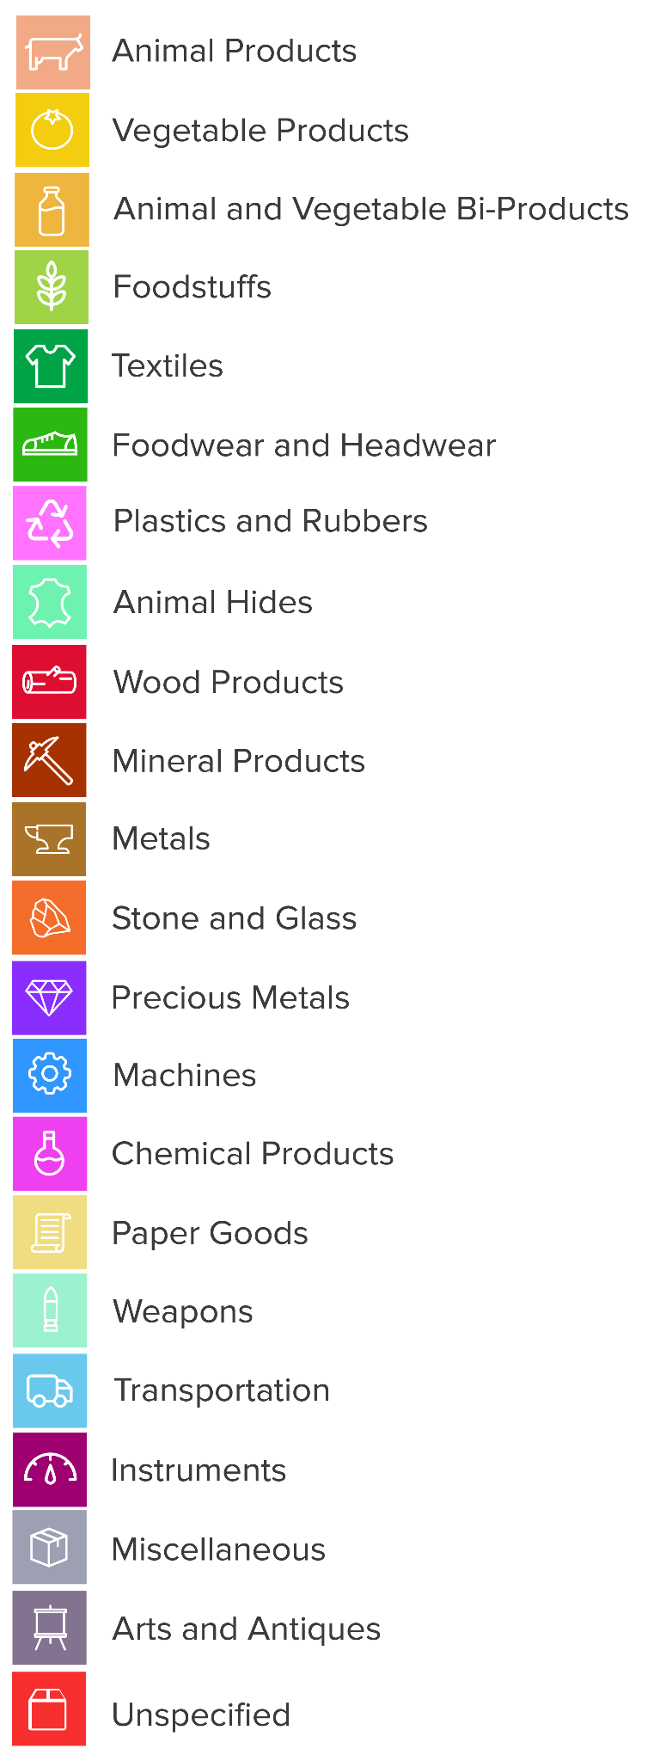

## 1 Data Sets

This analysis draws on two main datasets:

|  |  |  |  |
| --- | --- | --- | --- |
| **Domain** | **Source** | **Coverage** | **Granularity** |
| Trade flows | OEC (downloaded Feb 2025) | 2020–2023 | HS4 (1,223 products) |
| National accounts, human capital, and population | WDI (downloaded Feb 2025) | 1995–2023 | Country-year |

To ensure reliable complexity estimates, only products with at least US$500M in global trade across 2020–2023 were included. This filter removes extremely rare items that may distort product rankings.

## 2 Complexity & Relatedness​​

### **2.1 The Logic of Economic Complexity**

Economic complexity measures the knowledge embedded in a country’s export structure. The more diverse and sophisticated the products a country exports, the more productive knowledge it is understood to possess.

The **Economic Complexity Index (ECI)** assigns each country a score based on the average complexity of its specialized exports. The **Product Complexity Index (PCI)** assigns each product a score based on how exclusively it is exported by complex economies. This logic is recursive: complex economies export complex products, and complex products are exported by complex economies.

The mathematical foundation of ECI and PCI lies in the eigenvectors of matrices constructed from **Revealed Comparative Advantage (RCA)** data. A country is considered specialized in a product if it exports that product with RCA > 1. This binary specialization matrix (Mcp) is the basis for calculating both country and product complexity.

Formally:

$K$ of a location $c$ (e.g. country or city) be, $K_{c}$ and the complexity $K$ of an activity $p$ (e.g. product or industry) be $K_{p}$. Also, let $M_{cp}$ be a binary specialization matrix summarizing the activities $p$ present in each location $c$. $M_{cp}$ is defined as $M_{cp}$*= 1* when a location's output in an activity is larger than what is expected for a location of the same size and an activity with the same total output. This is done using an indicator of specialization known as a location's Revealed Comparative Advantage (RCA) $R_{cp}$.

That is,

$M_{cp}$ = 1 if $R_{cp}≥1$, where $R_{cp}$ = ${(X}_{cp} {X)/ {(X}_{c }X_{p}}_{})$,

where $X_{cp}$ is the volume of activity $p$ in location $c$ (e.g. exports of product ***p*** by country ***c***) and

$X_{c}=\sum_{p}{}X_{cp}$, ${X_{p}=\sum_{c}{}X_{cp}}_{}$, and ${X_{}=\sum_{cp}{}X_{cp}}_{}$.

Following this notation, the Economic Complexity Index is defined as a metric using the following two conditions:

*(i) The complexity of a location $K_{c}$ is a function $f$ of the complexity $K_{p}$ of the activities present in it $M_{cp}$,*

and,

*(ii) The complexity of an activity $K_{p}$ is a function $g$ of the complexity $K_{c}$ of the places where that activity is present $M_{cp}$.*

This logic is equivalent to the following mathematical map

$K_{c}=f(M_{cp},K_{p})$,

$K_{p}=g(M_{cp},K_{c})$,

where $f$ and $g$ are functions to be determined.

These maps imply that measures of the complexity of economies, or of economic activities, are solutions to self-consistent equations of the form:

$K_{c}=f(M_{cp},g(M_{cp},K_{c}))$,

$K_{p}=g(M_{cp},f(M_{cp},K_{p}))$,

which in many occasions can be reduced—or approximated by—a matrix equation of the form:

$K_{c}=M_{cc'}K_{c}$,

$$K_{p}=M_{pp'}K_{p}$$

The solution to these equations are the metrics of economic complexity for locations (Kc) and activities (Kp). Technically, these equations imply that metrics of economic complexity are the eigenvectors of matrices connecting similar economies ($M_{cc'}$) or similar activities ($M_{cc'}$).

These equations also tell us that complexity measures are relative since the complexity of a location or an activity can change because of changes in other locations or activities (other rows or columns in the $R_{cp}$ or $M_{cp}$ matrix).

In the above framework, the Economic Complexity Index of a location, or ECI, is defined as the average of the Product Complexity Index, or PCI, of the activities present in that location. Similarly, we define the Product Complexity Index of an activity, or PCI, as the average Economic Complexity Index, or ECI, of the locations where that activity is present. That is, $f$ and $g$ are simple averages and the ECI formula is the solution to the system of equations:

$K_{c}=\frac{1}{M_{c}}\sum_{p}{}M_{cp}K_{p}$,

$K_{p}=\frac{1}{M_{p}}\sum_{c}{}M_{cp}K_{c}$,

where $M_{c}= \sum_{p}{}M_{cp}$ is the number of activities (or diversity) of a location and $M_{p}=\sum_{c}{}M_{cp}$ is the ubiquity of an activity (number of locations where it is present)? Putting the second equation in the first one and solving the system is equivalent to diagonalizing the following matrix:

$$M_{cc'}=\frac{1}{M_{c}}\sum_{p}{}\frac{M_{cp}M_{c'p}}{M_{p}}.$$

Since Economic Complexity is a relative metric, the results are usually normalized using a Z-transform. That is:

$${ECI = \frac{K_{c}- mean(K_{c})}{std(K_{c})}}_{},$$

$${PCI = \frac{K_{p}- mean(K_{p})}{std(K_{p})}}_{},$$

where *mean*(*K*) and *std*(*K*) are respectively, the mean and the standard deviation of *K*.

The economic and product complexity indexes are also known to minimize the equation15:

And to be an optimal metric of distance to the technological frontier for log-supermodular matrices33.

### **2.2 Relatedness and the Product Space**

Diversification depends not only on what is valuable, but on what is **feasible** given a country’s current capabilities. This is where **relatedness** comes in.

Relatedness measures the **proximity** between a country’s current exports and a target product, based on how frequently pairs of products are exported together globally. This proximity is calculated using the **product space**, a network that connects products with similar input requirements.

Formally:

We estimate relatedness as the sum of the proximity of a product to all of the products that Rwanda specializes in and dividing that by the sum of the proximity between that product and all other products. That is, if the proximity between two products *p* and *p’* is $ϕ_{pp'}$, then the relatedness between an economy *c* and an activity *p* is given by:

$w_{cp}=\frac{\sum_{p'}{}M_{cp'}ϕ_{pp'}}{\sum_{p'}{}ϕ_{pp'}}$

Where *Mcp*=1 if the country is specialized in the activity *p* and 0 otherwise.

Relatedness ($w_{cp}$) is a number between 0 and 1, where 0 indicates that the product is not related to a country’s current pattern of specialization and 1 indicates that the product is highly related to the country’s current pattern of specialization.

## 3 Growth, Inequality & Emissions Models

### **Growth-Forecast Regression**

To estimate the relationship between economic complexity and income growth, we use a panel regression model covering 174 countries for the periods 1999–2009 and 2009–2019. The dependent variable is the annualized growth rate of GDP per capita (in PPP constant USD, 2021). The models control for log of initial GDP per capita and include specifications with and without the Economic Complexity Index (ECI) and its interaction with initial income.

|  |  |  |  |
| --- | --- | --- | --- |
| **Table 1. Economic complexity and growth** | | | |
|  | | | |
|  | *Dependent variable:* | | |
|  |  | | |
|  | Annualized growth of GDP per capita (in PPP constant (USD) (1999-09, 2009-19) | | |
|  | (1) | (2) | (3) |
|  | | | |
| ECI (trade) |  | 0.778*** | 1.002*** |
|  |  | (0.197) | (0.232) |
| ECI (trade) x log of initial GDP per capita |  |  | -0.426** |
|  |  |  | (0.197) |
| Log of initial GDP per capita | -0.714*** | -1.289*** | -1.421*** |
|  | (0.170) | (0.245) | (0.254) |
|  | | | |
| Observations | 174 | 174 | 174 |
| R2 | 0.084 | 0.156 | 0.178 |
| Adjusted R2 | 0.078 | 0.146 | 0.164 |
| Residual Std Error | 2.049 (df=172) | 1.972 (df=171) | 1.952 (df=170) |
| F Statistic | 17.692*** (df=172) | 13.830*** (df=171) | 10.421***(df=170) |
|  | | | |
| ***Notes:*** *Standard errors in parentheses *** p<0.01, ** p<0.05, * p<0.1.* | | | |

These coefficients are used to project the effect of changes in Rwanda’s ECI on future GDP per capita growth, comparing a Core No-Gold baseline scenario to an ECI-OPT scenario. Projections use the estimated coefficients from column (3), applying Rwanda’s observed or targeted ECI values and initial GDP per capita. All other variables are held at their observed values.

The regression results above provide the empirical foundation for these projections. For Rwanda, we set initial GDP per capita and ECI to their observed or target values to estimate expected growth rates under both Core No-Gold baseline and diversification scenarios.

### **Emissions-Forecast Regression**

To quantify the relationship between economic complexity and environmental performance, we estimate panel regressions linking the Economic Complexity Index (ECI) to CO₂ emissions intensity (emissions per unit of GDP), using country-level data from 1995–2022. The dependent variable is the natural logarithm of emissions intensity, capturing how efficiently countries generate output relative to their carbon footprint.

**Table 2. Economic complexity and emissions**

|  |  |  |  |
| --- | --- | --- | --- |
|  | | | |
|  | *Dependent variable:* | | |
|  |  | | |
|  | GHG emissions per unit of GDP, log (1996-99, 2000-03, 2004-07, 2008-11, 2012-15, 2016-18) | | |
|  | (1) | (2) | (3) |
|  | | | |
| ECI (trade) |  | -0.240*** | -0.236*** |
|  |  | (0.028) | (0.028) |
| ECI (trade), squared |  |  | -0.024*** |
|  |  |  | (0.017) |
| log of GDP per capita | 0.199*** | 0.138*** | 0.248*** |
|  | (0.029) | (0.031) | (0.044) |
|  | | | |
| Observations | 489 | 489 | 489 |
| R2 | 0.259 | 0.344 | 0.346 |
| Adjusted R2 | 0.258 | 0.341 | 0.342 |
| Residual Std. Error | 0.492 (df=487) | 0.464 (df=486) | 0.463 (df=485) |
| F Statistic | 164.559*** | 131.348*** | 90.106*** |
|  | | | |
| ***Notes:*** *Standard errors in parentheses *** p<0.01, ** p<0.05, * p<0.1.* | | | |

The coefficients from the preferred model (column 3) are used to estimate how Rwanda’s planned increase in ECI would affect its emission intensity.

The effect is:

* **Rwanda’s Core No-Gold baseline emission intensity:**
* **Scenario:**

A rise in Rwanda’s ECI from –0.45 to +0.18 is expected to lower emission intensity by approximately **21.6%**. This reduction reflects the benefits of structural transformation and complexity-driven industrial change, and occurs even before considering shifts in energy sources.

### **Inequality-Forecast Regression**

To estimate the relationship between economic complexity and income inequality, we use a panel regression model covering 320 country-periods from 1995–2022 (country fixed effects). The dependent variable is the Gini coefficient (net income). The models control for log initial GDP per capita and its square, and include specifications with ECI (trade) and its interaction with initial income.

**Table 3. Economic complexity and inequality**

|  |  |  |  |
| --- | --- | --- | --- |
|  | | | |
|  | *Dependent variable:* | | |
|  |  | | |
|  | GINI | | |
|  | (1) | (2) | (3) |
|  | | | |
| ECI (trade) |  | –4.689*** | –3.069*** |
|  |  | (0.527) | (0.491) |
| ECI (trade) x log of initial GDP per capita |  |  | –2.125*** |
|  |  |  | (0.494) |
| log of initial GDP per capita | 0.199*** | 0.138*** | –2.310*** |
|  | (0.029) | (0.031) | (0.523) |
| log of initial GDP per capita squared | 0.087 | 0.170 | 1.154** |
|  | (0.598) | (0.409) | (0.471) |
|  | | | |
| Observations | 320 | 320 | 320 |
| R2 | 0.360 | 0.583 | 0.609 |
| Adjusted R2 | 0.356 | 0.579 | 0.604 |
| Residual Std. Error | 5.023 (df=317) | 4.061 (df=316) | 3.938 (df=315) |
| F Statistic | 67.861*** | 127.502*** | 98.951*** |
|  | | | |
| ***Notes:*** *Standard errors in parentheses *** p<0.01, ** p<0.05, * p<0.1.* | | | |

These coefficients are used to estimate the effect of changes in Rwanda’s ECI on future income inequality, comparing a Core No-Gold baseline to a target ECI trajectory. Projections use the coefficients from column (3), applying Rwanda’s observed or projected ECI and GDP per capita values. Other variables are held at their observed values.

For Rwanda, scenario calculations use the observed or targeted ECI and GDP per capita, applying this equation to project expected Gini coefficients under different diversification scenarios.

## 4 Export-Portfolio Optimization (ECI-OPT)

To identify the most effective diversification strategy, this report applies the ECI-OPT method developed by Stojkoski & Hidalgo (2025). This approach moves beyond visual heuristics and directly solves for the optimal set of products that can raise Rwanda’s Economic Complexity Index (ECI) while minimizing the “effort” required to reach revealed comparative advantage (RCA) in new sectors.

Key Features of the Method

* Target Setting: The method first defines a target ECI for Rwanda, based on empirical growth benchmarks and the current structure of exports.
* Effort Minimization: For each potential new product, the required “effort” is calculated as the incremental increase in RCA Rwanda would need to achieve by a set target year (e.g., from RCA < 1 to RCA ≥ 1), using a stepping-stone year to model gradual progress.
* Model Inputs: The forecast of future RCA uses a multivariate regression including (a) past RCA, (b) relatedness, (c) relative relatedness, and (d) other control variables, all calibrated on historical trade data.
* Optimization Process: The algorithm searches for the smallest set of products which, if developed to RCA ≥ 1, would raise the average complexity (PCI) of Rwanda’s export basket above the target threshold. The cost function is the sum of RCA increases required.
* Forward-Looking: Unlike static diagrams, the model updates PCI values over time, adjusting for the potential that some products may become less complex as more countries enter those activities.

Advantages Over Standard Approaches

* Strategic Alignment: The method avoids sectoral biases and heuristics, focusing instead on the true cost-benefit trade-off for each product.
* Balanced Portfolio: ECI-OPT naturally recommends a mix of related and unrelated activities, balancing feasibility and long-term complexity gains.
* Empirical Foundation: Recommendations are grounded in observed patterns of trade evolution and robust out-of-sample forecasting performance.

Limitations

* The method assumes Rwanda is optimizing in isolation, without fully accounting for general equilibrium effects if multiple countries pursue the same strategy.
* ECI is optimized as a target, so policymakers must also address the institutional and organizational capabilities needed to realize the recommended portfolio.

Application in This Report

* For Rwanda, the model identifies a set of 52 products that—if developed—would raise the ECI from –0.45 to +0.18 by 2033.
* Each product is scored for (a) effort required, (b) complexity gain, and (c) expected contribution to ECI lift.
* Products are then grouped into three strategic clusters to guide policy, investment, and skill development priorities.

**Implementation Choices for Rwanda (project-specific)**

|  |  |  |
| --- | --- | --- |
| **Parameter** | **Value** | **Rationale** |
| Target ECI | +0.18 (≈ ½ σ gain) | Matches a 5 % p.a. GDP-per-capita growth scenario |
| Base year tt | 2023 trade matrix | Latest complete data |
| Stepping-stone ττ | 5 years (2028) | Allows policy lead-time |
| Horizon ΔtΔt | 10 years (2033) |  |
| Complexity band | PCI≤1 | 92% of peer successes lie here |
| Logistics filter | Unit value higher than US$1,654 per ton | Decreases the effects of high transportation costs |
| Objective | min⁡∑Wc,pmin∑Wc,p​ | Focus on least-cost upgrade |

Outcome: 52 products raise ECI from –0.45 to 0.18.

*Reference:* Stojkoski, V., & Hidalgo, C.A. (2025). Optimizing Economic Complexity. Toulouse School of Economics Working Paper 1623.

## 5 Cluster Snapshot and Full Product List

To translate Rwanda’s diversification strategy into a concrete path for investment, the 52 products identified through the ECI-OPT model are grouped into three strategic clusters. Each cluster reflects a distinct development logic and is anchored by flagship products that exemplifies the opportunity.

|  |  |  |  |  |
| --- | --- | --- | --- | --- |
| **Cluster** | **What it means** | **Flagship products (HS-4)** | **Representative adjacencies** | **Core capabilities to (start/upgrade)** |
| **Foundational Upgrades** | Quick wins from formulation/blending, packaging, and quality control that unlock immediate market access. | **3506** Glues & adhesives; **3819** Hydraulic brake fluids | **3304** Beauty/make-up & skin-care preps; **3306** Oral / dental hygiene preps; **3003** Medicaments (bulk); **3808** Insecticides / repellents; **2939** Vegetable alkaloids | Batch formulation; in-process QC; packaging / labeling & traceability; basic GMP documentation; dimensional QC (packaging/plastics); line hygiene |
| **Adjacent Growth** | Step-ups that require reactors, dispersion / milling, plastics conversion, tooling, and certifications to enter higher-value supply chains. | **3208** Paints & varnishes (aqueous); **3922** Plastic sanitary ware (baths / sinks / basins); **2922** Oxygen-function amino compounds | **3917** Plastic tubes / pipes / hoses; **4010** Rubber conveyor / transmission belts; **7003** Cast/rolled glass; **6912 / 6914** Ceramic ware & other ceramic articles; **6815** Articles of mineral substances; **8303/8304** Safes & filing cabinets; **8311**Soldering / welding wire / rods; **4809 / 4816 / 4901** Coated / printing papers & books; **8452** Sewing machines; **7018** Glass beads / imitation stones | Reactor operations; dispersion/milling & film performance; tooling & mold maintenance; tolerancing/fixtures; ISO 9001/14001 supplier qualification; EHS compliance; packaging/print QA |
| **Strategic Bets** | Knowledge- and certification-intensive niches that anchor clean assembly, metrology, and regulated-market entry—pulling capabilities toward the dense core. | **9018** Medical instruments; **8538** Parts for electrical apparatus; **8473** Office-machine / computer parts | **3917** Medical-grade/coated tubing; sterile disposables & kits (adjacent to **9018**, **3003**); selected diagnostic components | Clean-room routines; sterilization & traceability (ISO 13485); documentation; precision finishing; regulated-market onboarding |

Foundational Capability Upgrades (7)

* **2939** — Vegetable alkaloids
* **3003** — Medicaments (not in measured doses)
* **3304** — Beauty/make-up, skin-care preparations
* **3306** — Preparations for oral/dental hygiene
* **3506** — Prepared glues and other adhesives *(Flagship)*
* **3808** — Insecticides/rodenticides/fungicides/herbicides
* **3819** — Hydraulic brake fluids, anti-freezing preparations *(Flagship)*

Adjacent Growth Opportunities (34)

* **2823** — Titanium oxides
* **2922** — Oxygen-function amino-compounds *(Flagship)*
* **3208** — Paints & varnishes (aqueous medium) *(Flagship)*
* **3703** — Photographic paper/paperboard/textiles (coated media)
* **3917** — Plastic tubes, pipes, hoses
* **3922** — Plastic sanitary ware: baths/sinks/wash basins *(Flagship)*
* **4010** — Conveyor & transmission belts (vulcanised rubber)
* **4809** — Carbon paper, self-copy paper
* **4816** — Self-copy paper, duplicator stencils
* **4901** — Printed books, brochures
* **5401** — Sewing thread (man-made filaments)
* **5907** — Textile fabrics impregnated/covered for painting
* **5909** — Textile hosepiping & similar tubing
* **6601** — Umbrellas and sun-umbrellas
* **6812** — Fabricated asbestos fibers; mixtures with asbestos †
* **6815** — Articles of stone or other mineral substances
* **6912** — Ceramic table/kitchen-ware
* **6914** — Other ceramic articles
* **7003** — Cast/rolled glass
* **7018** — Glass beads; imitation stones
* **7418** — Copper table/kitchen articles
* **8203** — Files, rasps, pliers, scissors, hand tools
* **8211** — Knives with cutting blades
* **8303** — Safes/strong-boxes/cash boxes
* **8304** — Filing/card-index cabinets
* **8311** — Wire/rods/tubes/etc. of base metal for soldering/welding
* **8452** — Sewing machines
* **8474** — Machinery for sorting/screening/washing minerals
* **9207** — Keyboard musical instruments
* **9208** — Musical boxes/accordions
* **9608** — Ballpoint & felt-tip pens
* **9613** — Cigarette lighters
* **9617** — Vacuum flasks
* **9704** — Revenue stamps

Strategic Innovation Bets (11)

* **8473** — Office-machine/computer parts *(Flagship)*
* **8518** — Loudspeakers/headphones/microphones
* **8519** — Sound recording/reproducing equipment
* **8538** — Parts for electrical apparatus (8535–8537) *(Flagship)*
* **8539** — Electric filament/discharge lamps
* **8703** — Motor cars and other vehicles
* **8803** — Aircraft/spacecraft parts
* **9007** — Cinematographic cameras/projectors
* **9018** — Medical instruments *(Flagship)*
* **9025** — Hydrometers/thermometers/pyrometers/barometers
* **9402** — Medical/surgical/dental/veterinary furniture

|  |  |  |  |  |  |  |  |
| --- | --- | --- | --- | --- | --- | --- | --- |
| **Cluster** | **HS Code** | **Product name** | **Current RCA** | **Current Relative Relatedness** | **PCI** | **Target ECI** | **Target Growth** |
| Adjacent Growth Opportunities | 2823 | Titanium oxides | 0.203 | -1.057 | 0.847 | 0.06 | 4.825 |
| Adjacent Growth Opportunities | 2922 | Oxygen-function amino-compounds | 0.3 | -0.48 | 0.704 | 0.01 | 4.743 |
| Foundational Capability Upgrades | 2939 | Vegetable alkaloids | 0.844 | -0.859 | 0.417 | -0.34 | 4.17 |
| Foundational Capability Upgrades | 3003 | Medicaments (not in measured doses) | 0.287 | 0.186 | 0.645 | 0.16 | 4.989 |
| Adjacent Growth Opportunities | 3208 | Paints & varnishes (aqueous medium) | 0.458 | 0.732 | 0.587 | -0.14 | 4.498 |
| Foundational Capability Upgrades | 3304 | Beauty/make-up, skin-care preparations | 0.366 | 0.104 | 0.515 | 0.17 | 5.006 |
| Foundational Capability Upgrades | 3306 | Preparations for oral/dental hygiene | 0.846 | 0.245 | 0.251 | -0.39 | 4.088 |
| Foundational Capability Upgrades | 3506 | Prepared glues and other adhesives | 0.271 | -0.44 | 0.853 | -0.04 | 4.661 |
| Adjacent Growth Opportunities | 3703 | Photographic paper, paperboard, textiles | 0.151 | -0.931 | 0.949 | 0.11 | 4.907 |
| Foundational Capability Upgrades | 3808 | Insecticides, rodenticides, fungicides, herbicides | 0.758 | 0.613 | 0.179 | -0.29 | 4.252 |
| Foundational Capability Upgrades | 3819 | Hydraulic brake fluids, anti-freezing preparations | 0.422 | -0.299 | 0.86 | -0.19 | 4.416 |
| Adjacent Growth Opportunities | 3917 | Plastic tubes, pipes, hoses | 0.645 | 1.024 | 0.046 | 0.17 | 5.006 |
| Adjacent Growth Opportunities | 3922 | Baths, sinks, wash basins, plastic sanitary ware | 0.546 | 0.173 | 0.554 | -0.14 | 4.498 |
| Adjacent Growth Opportunities | 4010 | Conveyor belts, transmission belts, of vulcanised rubber | 0.161 | -0.327 | 0.938 | 0.06 | 4.825 |
| Adjacent Growth Opportunities | 4809 | Carbon paper, self-copy paper | 0.886 | -0.488 | 0.394 | -0.39 | 4.088 |
| Adjacent Growth Opportunities | 4816 | Carbon paper, self-copy paper, duplicator stencils | 0.204 | -1.207 | 0.862 | 0.16 | 4.989 |
| Adjacent Growth Opportunities | 4901 | Printed books, brochures | 0.448 | 0.159 | 0.816 | -0.19 | 4.416 |
| Adjacent Growth Opportunities | 5401 | Sewing thread of man-made filaments | 0.897 | 0.79 | -0.322 | -0.29 | 4.252 |
| Adjacent Growth Opportunities | 5907 | Textile fabrics impregnated/covered with preparations for painting | 0.651 | -0.65 | 0.723 | -0.29 | 4.252 |
| Adjacent Growth Opportunities | 5909 | Textile hosepiping and similar tubing | 0.257 | -0.699 | 0.892 | -0.04 | 4.661 |
| Adjacent Growth Opportunities | 6601 | Umbrellas and sun umbrellas | 0.712 | -0.491 | 0.043 | -0.09 | 4.579 |
| Adjacent Growth Opportunities | 6812 | Fabricated asbestos fibers; mixtures with asbestos | 0.984 | 0.26 | 0.02 | -0.39 | 4.088 |
| Adjacent Growth Opportunities | 6815 | Articles of stone or other mineral substances | 0.18 | -0.483 | 0.96 | 0.01 | 4.743 |
| Adjacent Growth Opportunities | 6912 | Ceramic tableware, kitchenware | 0.448 | -0.301 | 0.447 | -0.09 | 4.579 |
| Adjacent Growth Opportunities | 6914 | Ceramic articles | 0.487 | -0.256 | 0.391 | 0.06 | 4.825 |
| Adjacent Growth Opportunities | 7003 | Cast glass and rolled glass | 0.752 | -1.238 | 0.849 | -0.34 | 4.17 |
| Adjacent Growth Opportunities | 7018 | Glass beads, imitation pearls, precious/semi-precious stones | 0.212 | -0.979 | 0.948 | 0.01 | 4.743 |
| Adjacent Growth Opportunities | 7418 | Table, kitchen articles of copper | 0.528 | -0.639 | 0.345 | 0.01 | 4.743 |
| Adjacent Growth Opportunities | 8203 | Files, rasps, pliers, scissors, hand tools | 0.614 | -0.678 | 0.685 | -0.24 | 4.334 |
| Adjacent Growth Opportunities | 8211 | Knives with cutting blades | 0.277 | -1.136 | 0.807 | -0.04 | 4.661 |
| Adjacent Growth Opportunities | 8303 | Safes, strong-boxes, cash/valuables boxes | 0.216 | -0.553 | 0.799 | 0.16 | 4.989 |
| Adjacent Growth Opportunities | 8304 | Filing cabinets, card-index cabinets | 0.403 | -0.43 | 0.714 | -0.09 | 4.579 |
| Adjacent Growth Opportunities | 8311 | Wire, rods, tubes, etc. of base metal for soldering, welding | 0.966 | 0.136 | 0.635 | -0.44 | 4.006 |
| Adjacent Growth Opportunities | 8452 | Sewing machines | 0.902 | -0.346 | 0.128 | -0.39 | 4.088 |
| Strategic Innovation Bets | 8473 | Parts and accessories for office machines, computers | 0.147 | -1.065 | 0.984 | 0.11 | 4.907 |
| Adjacent Growth Opportunities | 8474 | Machinery for sorting, screening, washing, mineral substances | 0.479 | -0.11 | 0.645 | -0.24 | 4.334 |
| Strategic Innovation Bets | 8518 | Loudspeakers, headphones, microphones | 0.611 | -0.72 | 0.828 | -0.29 | 4.252 |
| Strategic Innovation Bets | 8519 | Sound recording/reproducing equipment | 0.852 | -0.85 | 0.824 | -0.44 | 4.006 |
| Strategic Innovation Bets | 8538 | Parts for electrical apparatus of 8535–8537 | 0.115 | -0.255 | 0.997 | 0.06 | 4.825 |
| Strategic Innovation Bets | 8539 | Electric filament/discharge lamps | 0.352 | -0.602 | 0.943 | -0.09 | 4.579 |
| Strategic Innovation Bets | 8703 | Motor cars and other vehicles | 0.127 | -0.381 | 0.951 | 0.11 | 4.907 |
| Strategic Innovation Bets | 8803 | Parts of aircraft and spacecraft | 0.71 | -0.833 | 0.887 | -0.34 | 4.17 |
| Strategic Innovation Bets | 9007 | Cinematographic cameras and projectors | 0.415 | -0.002 | 0.813 | -0.19 | 4.416 |
| Strategic Innovation Bets | 9018 | Medical instruments | 0.283 | -0.52 | 0.892 | -0.04 | 4.661 |
| Strategic Innovation Bets | 9025 | Hydrometers, thermometers, pyrometers, barometers | 0.142 | -0.793 | 0.927 | 0.16 | 4.989 |
| Adjacent Growth Opportunities | 9207 | Musical instruments, keyboards | 0.599 | -1.15 | 0.772 | -0.24 | 4.334 |
| Adjacent Growth Opportunities | 9208 | Musical boxes, fairground organs, accordions | 0.922 | -0.886 | 0.668 | -0.44 | 4.006 |
| Strategic Innovation Bets | 9402 | Medical, surgical, dental, veterinary furniture | 0.143 | -0.435 | 0.947 | 0.11 | 4.907 |
| Adjacent Growth Opportunities | 9608 | Ballpoint pens, felt tipped pens | 0.346 | -0.747 | 0.691 | -0.04 | 4.661 |
| Adjacent Growth Opportunities | 9613 | Cigarette lighters | 0.897 | -0.271 | 0.075 | -0.34 | 4.17 |
| Adjacent Growth Opportunities | 9617 | Vacuum Flask | 0.635 | -1.225 | 0.472 | -0.19 | 4.416 |
| Adjacent Growth Opportunities | 9704 | Revenue Stamps | 0.406 | -0.211 | 0.841 | -0.14 | 4.498 |

## REFERENCES —

**1** | Hidalgo, C. A. Economic complexity theory and applications. *Nature Reviews Physics* 1–22 (2021).

**2** | Hidalgo, C. A., Klinger, B., Barabási, A.-L. & Hausmann, R. The Product Space Conditions the Development of Nations. *Science* 317, 482–487 (2007).

**3** | Hidalgo, C. A. & Hausmann, R. The building blocks of economic complexity. *PNAS* 106, 10570–10575 (2009).

**4** | Hidalgo *et al*. The Principle of Relatedness. in *Unifying Themes in Complex Systems IX* (eds. Morales, A. J., Gershenson, C., Braha, D., Minai, A. A. & Bar-Yam, Y.) 451–457 (Springer International Publishing, 2018).

**5** | Hausmann, R. *et al*. *The atlas of economic complexity: Mapping paths to prosperity.* (MIT Press, 2014).

**6** | Simoes, A. J. G. & Hidalgo, C. A. The economic complexity observatory: An analytical tool for understanding the dynamics of economic development. in *Workshops at the twenty-fifth AAAI conference on artificial intelligence* (2011).

**7** | Stojkoski, V. & Kocarev, L. The relationship between growth and economic complexity: evidence from Southeastern and Central Europe. (2017).

**8** | Hidalgo, C. *Why information grows: The evolution of order, from atoms to economies.* (Basic Books, New York, 2015).

**9** | Domini, G. Patterns of specialization and economic complexity through the lens of universal exhibitions, 1855-1900. *Explorations in Economic History* 83, 101421 (2022).

**10** | Chávez, J. C., Mosqueda, M. T. & Gómez-Zaldívar, M. Economic complexity and regional growth performance: Evidence from the Mexican Economy. *Review of Regional Studies* 47, 201–219 (2017).

**11** | Poncet, S. & de Waldemar, F. S. Economic Complexity and Growth. *Revue économique* 64, 495–503 (2013).

**12** | Ourens, G. Uruguay al espejo: Análisis de la estructura productiva uruguaya a través del Método de los Reflejos. *Revista de economía* 19, 99–142 (2012).

**13** | Stojkoski, V., Utkovski, Z. & Kocarev, L. The Impact of Services on Economic Complexity:

Service Sophistication as Route for Economic Growth. *PLOS ONE* 11, e0161633 (2016).

**14** | Koch, P. Economic Complexity and Growth: Can value-added exports better explain the link? *Economics Letters* 198, 109682 (2021).

**15** | Hartmann, D., Guevara, M. R., Jara-Figueroa, C., Aristarán, M. & Hidalgo, C. A. Linking Economic Complexity, Institutions, and Income Inequality. *World Development* 93, 75–93 (2017).

**16** | Bandeira Morais, M., Swart, J. & Jordaan, J. A. Economic Complexity and Inequality: Does Productive Structure Affect Regional Wage Differentials in Brazil? *USE Working Paper series* 18, (2018).

**17** | Chu, L. K. & Hoang, D. P. How does economic complexity influence income inequality? New evidence from international data. *Economic Analysis and Policy* 68, 44–57 (2020).

**18** | Fawaz, F. & Rahnama-Moghadamm, M. Spatial dependence of global income inequality: The role of economic complexity. *The International Trade Journal* 33, 542–554 (2019).

**19** | Hartmann, D. & Pinheiro, F. L. *Economic complexity and inequality at the national and regional level.* http://arxiv.org/abs/2206.00818 (2022) doi:10.48550/arXiv.2206.00818.

**20** | Romero, J. P. & Gramkow, C. Economic complexity and greenhouse gas emissions. *World Development* 139, 105317 (2021).

**21** | Neagu, O. & Teodoru, M. C. The relationship between economic complexity, energy consumption structure and greenhouse gas emission: Heterogeneous panel evidence from the EU countries. *Sustainability* 11, 497 (2019).

**22** | Neagu, O. The Link between Economic Complexity and Carbon Emissions in the

European Union Countries: A Model Based on the Environmental Kuznets Curve (EKC) Approach. *Sustainability* 11, 4753 (2019).

**23** | Gozgor, G. & Can, M. Export product diversification and the environmental Kuznets curve: evidence from Turkey. *Environmental Science and Pollution Research* 23, 21594–21603 (2016).

**24** | Can, M. & Gozgor, G. The impact of economic complexity on carbon emissions: evidence from France. *Environmental Science and Pollution Research* 24, 16364–16370 (2017).

**25** | Lapatinas, A., Garas, A., Boleti, E. & Kyriakou, A. Economic complexity and environmental performance: Evidence from a world sample. (2019).

**26** | Gao, J. & Zhou, T. Quantifying China’s regional economic complexity. *Physica A: Statistical Mechanics and its Applications* 492, 1591–1603 (2018).

**27** | Guevara, M. R., Hartmann, D., Aristarán, M., Mendoza, M. & Hidalgo, C. A. The research space: using career paths to predict the evolution of the research output of individuals, institutions, and nations. *Scientometrics* 109, 1695–1709 (2016).

**28** | Balland, P.-A. & Rigby, D. The Geography of Complex Knowledge. *Economic Geography* 93, 1–23 (2017).

**29** | Barza, R., Jara-Figueroa C., Hidalgo C., *Viarengo M., Knowledge Intensity and Gender Wage Gaps: Evidence from Linked Employer-Employee Data*, (2020

**30** | Stojkoski, V., Koch, P. & Hidalgo, C. A. Multidimensional Economic Complexity: How the Geography of Trade, Technology, and Research Explain Inclusive Green Growth. Preprint at https://doi.org/10.48550/arXiv.2209.08382 (2022).

**31** | Fritz, B. S. & Manduca, R. A. The economic complexity of US metropolitan areas. *Regional Studies* 1–12 (2021).

**32** | Chu, Lan Khanh, and Dung Phuong Hoang. "How does economic complexity influence income inequality? New evidence from international data." Economic Analysis and Policy 68 (2020): 44-57

**33** | Schetter U. "A Measure of Countries’ Distance to Frontier Based on Comparative Advantage”

**34 |** Stojkoski, Viktor, and César A. Hidalgo. 2025. “Optimizing Economic Complexity.” Working Paper TSE‑16‑23, Toulouse School of Economics.

**35 |** Senthilkumar, K., Kibret, K., & Mponda, O. (2021). "Fertilizer response and nutrient management in sub-Saharan Africa: Lessons from maize systems." Field Crops Research, 271, 108239.

https://doi.org/10.1016/j.fcr.2021.108239

### 

### 

### 

### 

### 

### 

### 

### 

*All trade statistics (exports, imports) and calculations (RCA, PCI, Relatedness) use* ***OEC data****, February 2025 download.*

1. More details on guiding funds can be found in: *The Infinite Alphabet: And the Laws of Knowledge* by César A. Hidalgo (Penguin, UK) (2025).